**User Guide Version March 2021**

**Implementing Framework Contract**

**GSA/OP/09/16/Lot 2/SC 8**

Table of Contents

Table of Contents 2

1. Mobile Application - Android 4

1.1 Installation 4

1.1.1 Installation from app store 4

1.1.2 Installing from APK 4

1.1.3 Compiling from source code 4

1.1.4 Minimal requirements 5

1.2 Application Start and Permissions 5

1.2.1 Login 6

1.3 Main Screen 7

1.3.1 Task List 9

1.3.2 Task detail 10

1.3.3 Standalone Snapshots 12

1.3.4 Camera Mode 14

1.3.5 Map 16

1.3.6 Paths 19

1.3.7 GNSS Raw Data 20

1.4 About 22

1.5 Settings 23

2. Mobile Application - iOS 25

2.1 Installation 25

2.1.1 Installation from App Store or via TestFlight 25

2.1.2 Compiling from source code 25

2.1.3 Minimal requirements 25

2.2 Application Start and Permissions 25

2.2.1 Login 25

2.3 Main Screen 26

2.3.1 Task List 27

2.3.2 Task detail 28

2.3.3 Standalone Snapshots 30

2.3.4 Camera Mode 32

2.4 Map 33

2.4.1 Paths 34

2.5 About 34

2.6 Settings 35

3. Web Console Interface 37

3.1 User roles 37

3.2 Farmer access 38

3.2.1 Task List 38

3.2.2 Task Detail page 39

3.2.3 Standalone photos gallery 40

3.2.4 Photo gallery 43

3.2.5 User paths 44

3.2.6 Generating PDF documents 45

3.2.7 Map 47

3.3 Administrator 49

3.3.1 User management 49

3.3.2 Farmer Detail 50

3.3.3 Task Detail 52

3.4 Super-administrator 54

3.4.1 Agency list 54

3.4.2 Agency detail 55

4. Annex: Hosting and installing the EGNSS4CAP web console 56

4.1 Hosting requirements 56

4.2 Server resources requirements 56

4.3 Installation steps for the webconsole 56

# Mobile Application - Android

## Installation

### Installation from app store

The application for Android phones is distributed via Google Play Store service. (<https://support.google.com/googleplay/answer/113409?hl=en&ref_topic=2450266>).

The application is currently in the Closed Testing Alpha channel (status 31/03/2021). Each user has to be registered with their Google Account.

The production version will be released to the production channel in the future without the limitation mentioned above.

### Installing from APK

Follow these steps to install the application from an apk file. The details of these steps will vary depending on your version of Android and the manufacturer of your device.

1. Download the apk file (package) to your phone either by transferring files via PC or via a mobile web browser.
2. Make sure in the settings according to your version of Android that you are allowed to install third-party applications.
3. Use the embedded file manager application on your mobile device, where the apk file is stored, or download such an application.
4. Once you find the apk in the file manager, tap on it to install.
5. Follow the instructions in the dialog that appears until the installation is successful.

### Compiling from source code

The source code and the directory structure are compatible and meet the requirements for the Android Studio project in which it was created.

You must have Android Studio installed on your PC to compile the application. Android Studio can be downloaded here: <https://developer.android.com/studio>.

You also need to have Gradle build automation tools, at least version 4.1.2, running in the Android Studio.

To build and run an application, open the source code of the application as an Android Studio project and execute the build command and then execute the run command. At the same time, you must also have downloaded all the dependencies and libraries that are ordered by the gradle configuration files.

More detailed information on how to compile and work with source codes in Android Studio can be found here: <https://developer.android.com/studio/run>.

### Minimal requirements

Android:

* Minimal version of Android: 6.0 Marshmallow (API 23)
* Disk space: 100MB (only a standalone application without a large amount of user data)
* RAM: 1GB
* Sensors: gyroscope, magnetometer, accelerometer
* Inputs: camera, Wi-Fi or data mobile service, location service
* Apps: Google Play services

## Application Start and Permissions

The application can be run on Android devices by selecting it in the list of applications (Fig. 1).



Fig. 1 Application icon

Upon the first start of the application, user permissions will be requested, which are required to correctly run the application.

* Location services
  + to assign location data to photos
  + to distinguish between various types of location data or signals on the device
  + to use the path tracking feature
* Camera and Video
  + to use the device camera for the snapshot capturing feature
* Make and manage calls
  + to assign data of the mobile network or the WIFI network to captured snapshots as input to geotagged information

In the case that any of mentioned permissions is not allowed by the user, the application is not able to work properly. Thus, the dialog requesting such permissions is shown to the user (Fig. 2).

A user is able to invoke the Android system permissions dialog again by clicking the “*Confirm Permissions*“ button. If these dialogs have been banned by the user, there is still the possibility to set permissions in the System settings before the application start. This procedure may vary on different Android devices and system versions.

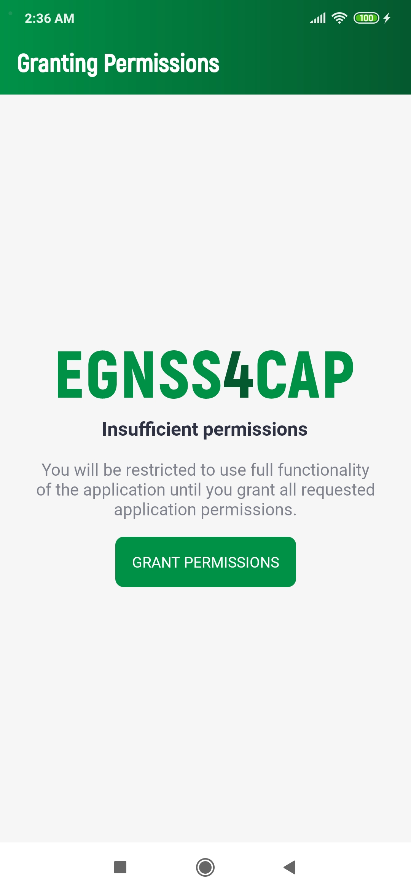

Fig. 2 Permissions request

### Login

After the first launch of the application and granting all the necessary permissions to the application, the user will be presented with a login screen (Fig. 3), where the assigned login and password will need to be filled out. Click the *Sign In* button to complete the login.

To successfully log in, all data most be entered correctly and the device should be connected to the Internet at the time of login. The login details will be remembered for future uses of the app. Re-login will be required only after explicit logout of the user. After each login, the synchronization process (*Main screen*) starts automatically.

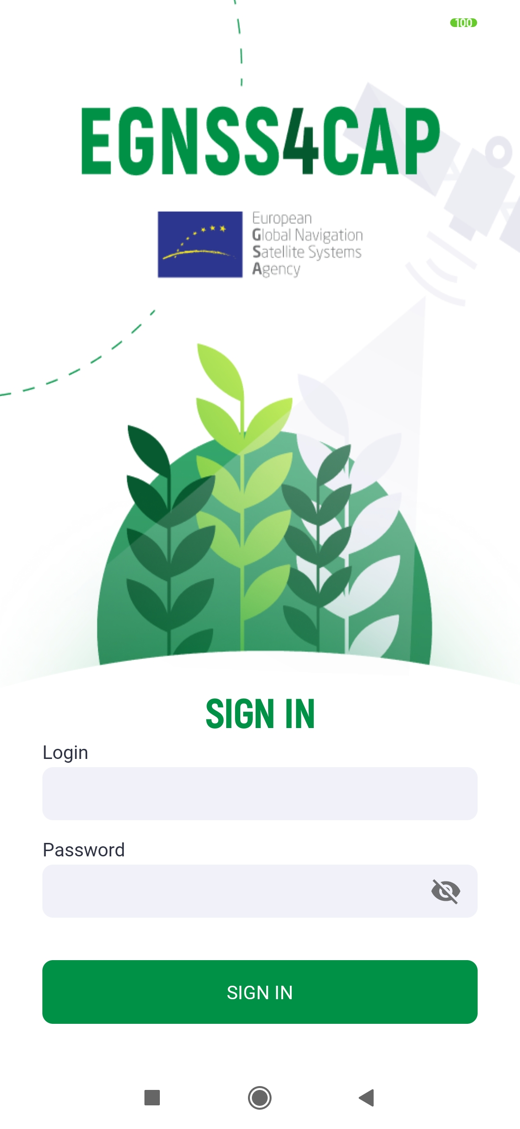

Traffic lights

Device capabilities show the current ability of the device to receive location data.

* Green indicates the active ability of the phone to determine its current location.
* Red means an inability to determine your current position. If this is the case, location services on the device may be disabled.

Other attributes use the green or yellow color.

* Green indicates that the device has that particular property. Yellow indicates that the device does not have the given property or has not yet been able to verify the given availability and may change to green over time.

Other items representing the individual properties of the device, which are listed below, can only be green or yellow. Each yellow item may change to green over time. The opposite statement does not apply, and the green item will remain green forever.

* Compass and gyroscope
* Galileo capability
* Dual frequency support
* EGNOS
* Galileo Navigation messages

Fig. 3 Login screen

## Main Screen

In the upper section of the Main screen, the “Logged in user” field can be found, which provides information about the currently logged in user.

The attributes of the host device are displayed in the middle of the “Basic Information” section. Traffic lights are displayed next to some of the attributes. Their detailed description is given in the sidebar and can also be found in the *About screen*.

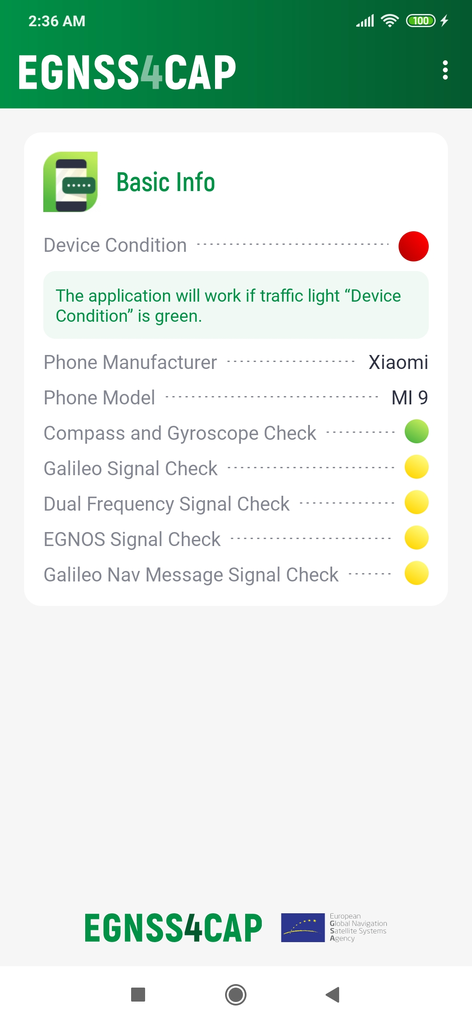

Fig. 4 Main screen

To navigate between the different application modules, a main menu opens when you click on the three dots in the upper right corner of the screen. The context menu has the following options:

* Synchronize
  + Starts the process of synchronizing data with the server. You cannot use the application during synchronization and you must be connected to the internet.
* Task Overview
  + Displays the task list screen
* Unassigned Photos
  + Displays the list of standalone photos, which are not assigned to the specific task
* Map
  + Changes the screen to the map view with all taken photos
* Path Tracking
  + Changes the screen to the map view for taking new paths or viewing paths that have already been taken
* Settings
  + Allows the user to change the settings
* GNSS Raw Data
  + Displays an overview of currently received GNSS data
* About
  + Shows basic information about the application
* Log out
  + User log out, reverts to the login screen

### Task List

In the task overview (Fig. 5), user tasks are listed by name, status, number of captured images, creation date and due date. By clicking on a specific task, a screen with details and options to edit is displayed.

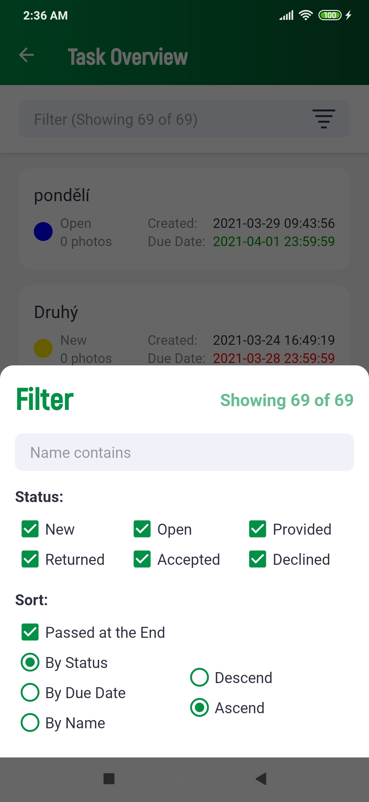

Fig. 5 Task list

The go-up filter (by tapping the Filter bar at the top of the screen) restricts the task list by task name and status. In the filter, you can also set the sorting of images in the list according to the options offered. When the *Expired* option is selected, the sort is divided into two depending on whether the due date has passed or not. The sorted list of tasks will be displayed for each group independently. The group of tasks with expired due dates (*Due date* marked in red in each item in the list) will be included at the end.

The filter settings are retained even after the application is closed.

Tasks can be set in following states, which also determine their editability:

|  |  |  |
| --- | --- | --- |
| Description | | Editable |
|  | **New** A new task | **YES** |
|  | **Open**  A new task, which has been already displayed by the user. The user is aware of the task. | **YES** |
|  | **Returned** The has been returned by the officer to the farmer with an additional information request. | **YES** |
|  | **Data provided**  The task which was completed and sent by the farmer to the PA | **NO** |
|  | **Data confirmed (approved task)**  The completed task has been approved. | **NO** |
|  | **Data checked (rejected)**  The completed tsk has been rejected. | **NO** |
|  | **Closed**  The task has been closed is not active. | **NO** |

To ensure that all tasks are current, the user must manually start the synchronization process (M).

### Task detail

The task detail (Fig. 6) shows the data attributes of the task, including all captured images. Depending on the status of the task, the task can either be edited or viewed.

* The upper section lists the basic data attributes of the task.
* The *Instructions* section shows the description needed to complete the task given by an authorized staff member of the Paying Agency.
* The *Reason for return* section describes the reason for the Paying Agency why the task was returned for a new performance.
* The *Note* section is completed by the user as part of completing the task before it is submitted.
* The photo section shows thumbnails of photos taken. The user takes photos by clicking the button 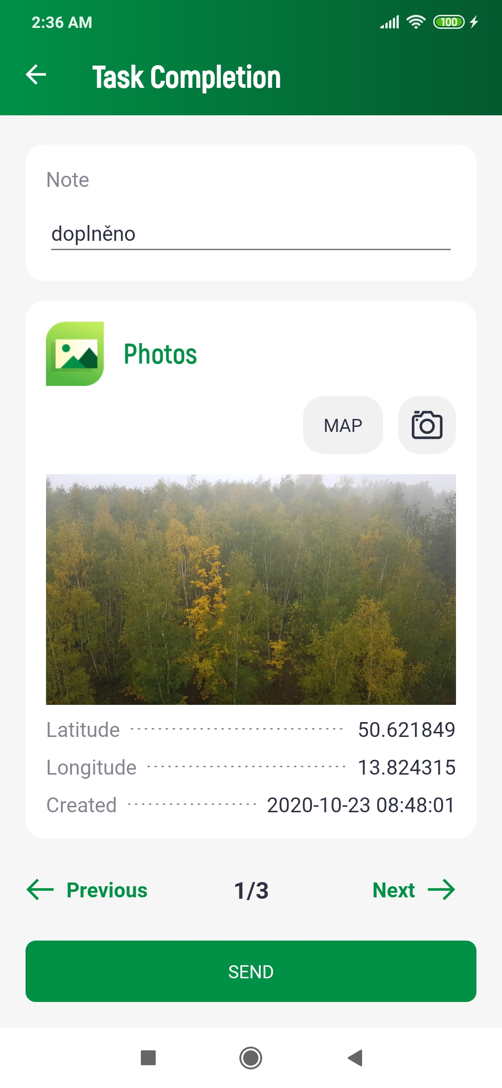, which enters the camera mode for shooting (Camera Mode). Tap to delete the currently displayed photo 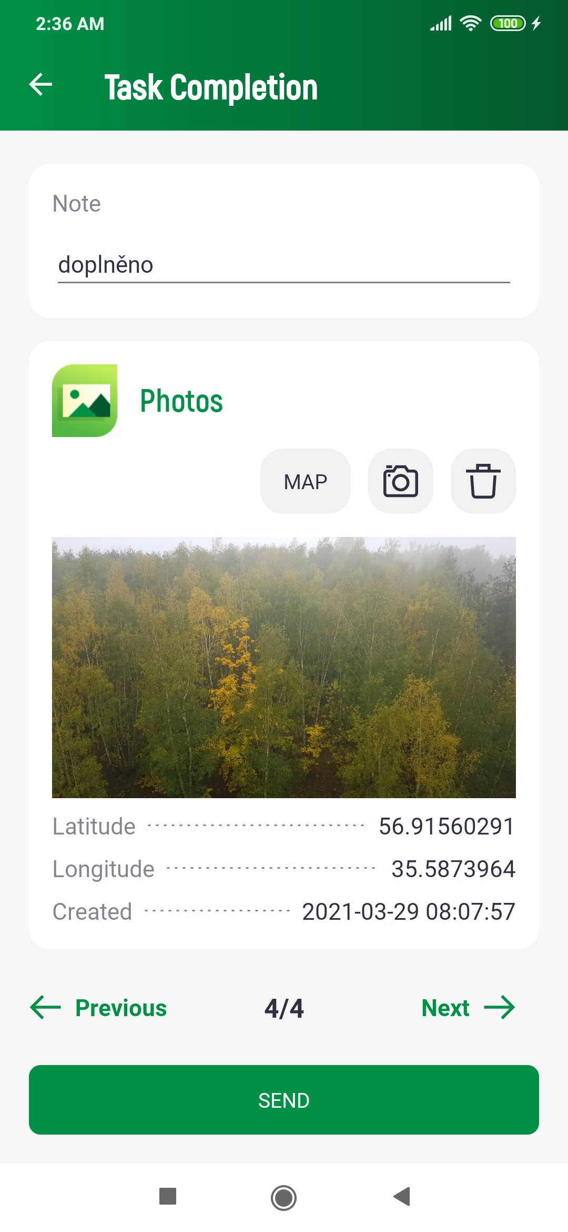.
* The *MAP* button shows all photos of the task in the map view.
* Use the buttons *Previous* and *Next* to move between photo previews.

A photo cannot be deleted if it has been already sent to the server, even if the task is in an editable state.

Click the *SEND* button to send the message. After successful submission, the task can no longer be edited. If an error occurs during sending process, for example if the Internet connection was not strong enough at the time of sending, the task will be locked. In the locked state, the task is non-editable and the user can only retry its successful submission, or remove this locked state by starting the synchronization process.

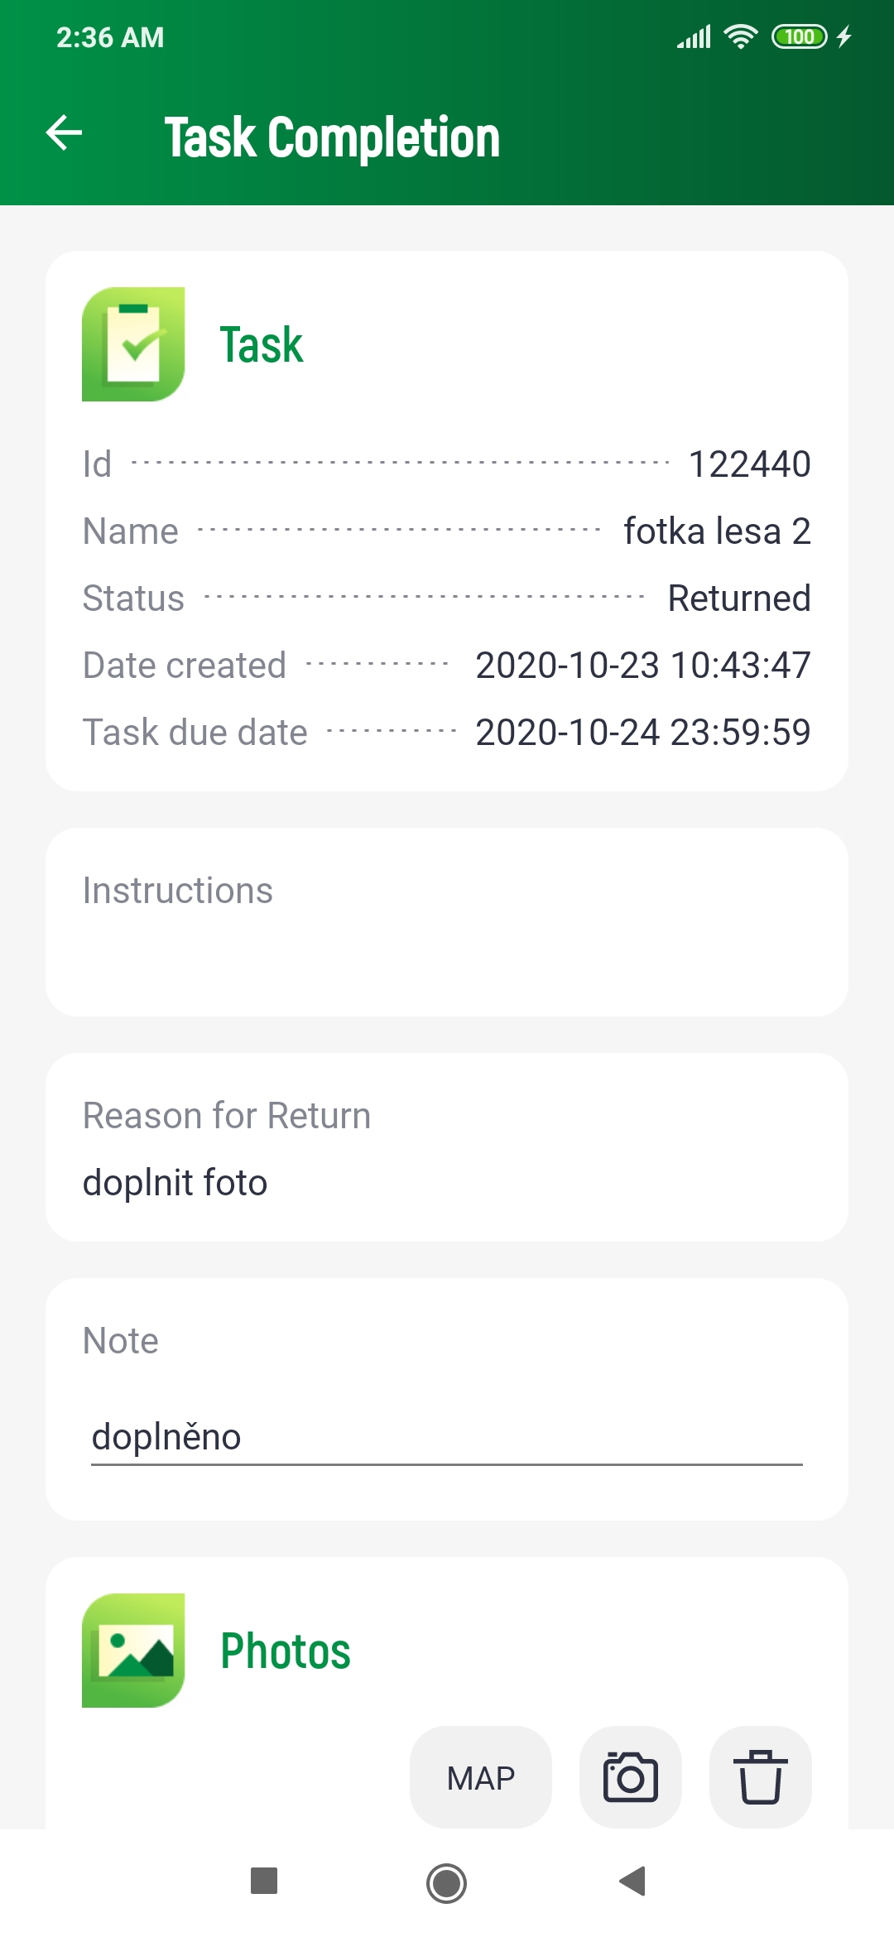

Fig. 6 Task edit

Clicking on the photo preview will open a window with its detail (Fig. 7). The basic attributes of the photo are displayed in the upper left corner. In this view, you can switch views between all photos of the task using the buttons 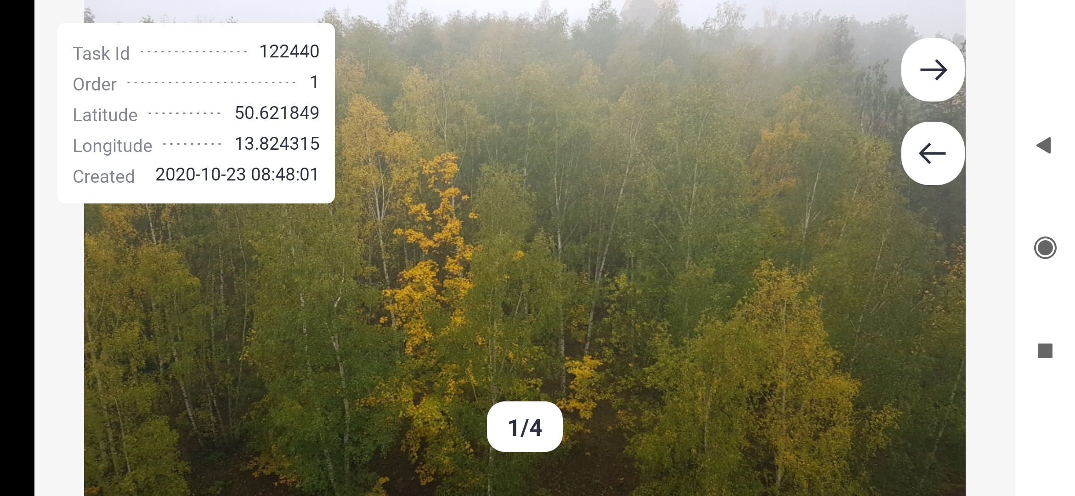 and , or by swiping your finger on the photo to the right or left. The screen *Detail* supports displaying in portrait or in landscape mode. If possible, the photo can also be deleted from this view with the button .

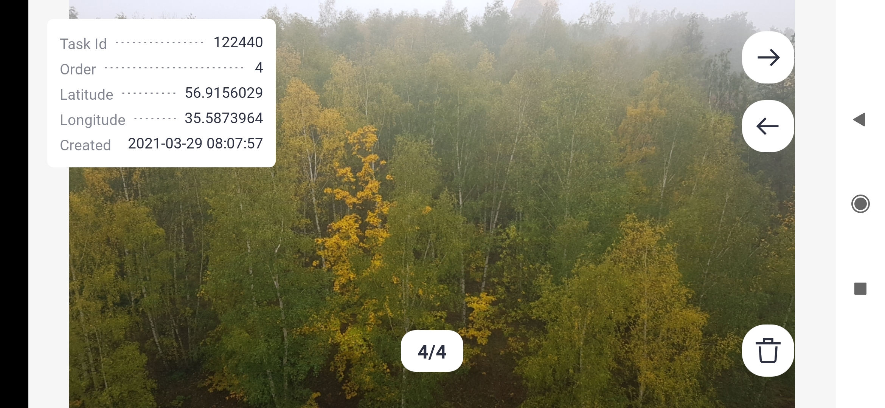

Fig. 7 Photo detail

### Standalone Snapshots

Screen showing photos in the list (Fig. 8) taken separately outside the task. In each list item, on the left is a preview of the photo and on the right a list of basic metadata.

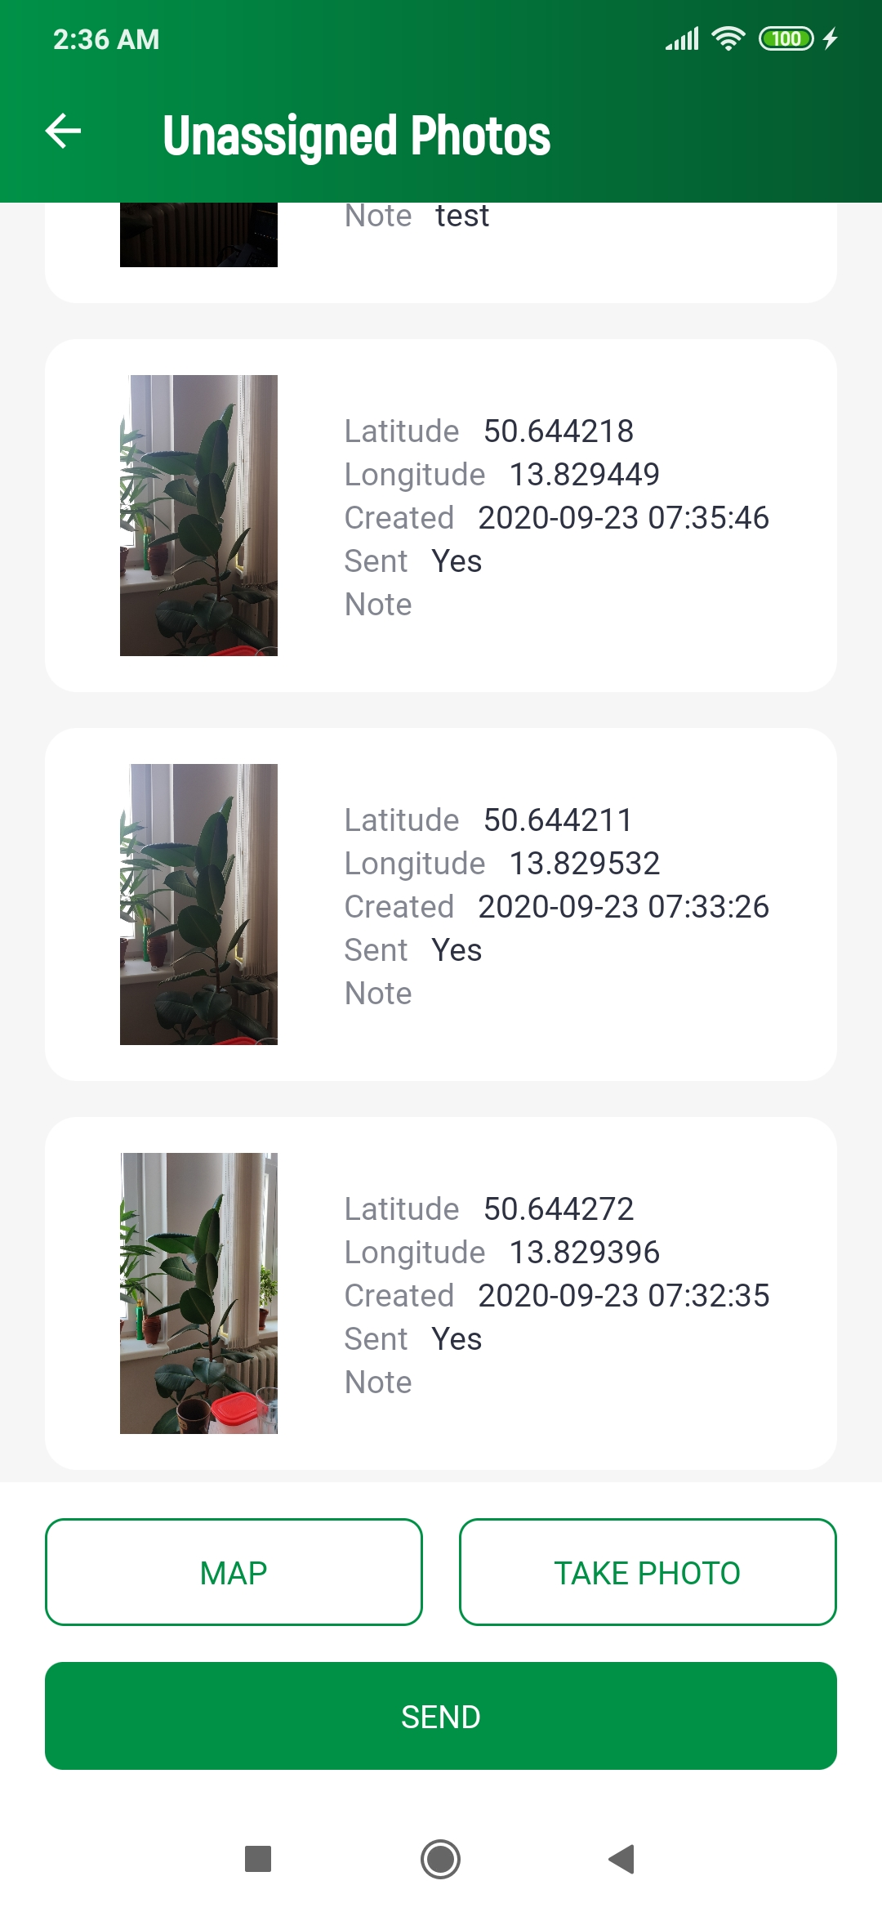

Fig. 8 Overview of standalone photos

From this screen, new photos are taken by touching of a button *TAKE PHOTO*, which enters the user to take camera mode (Camera Mode). Click the *SEND* button to send all newly taken unsent photos in the list. The *MAP* button shows all these photos in the map view.

Clicking on a photo item in the list opens its detail (Fig. 9), where the editing is performed using the buttons at the bottom of the screen.

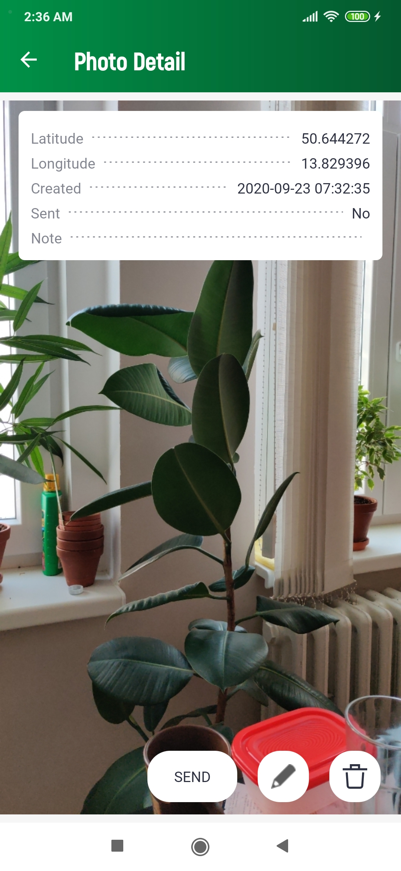

Fig. 9 Detail of a standalone photo

* 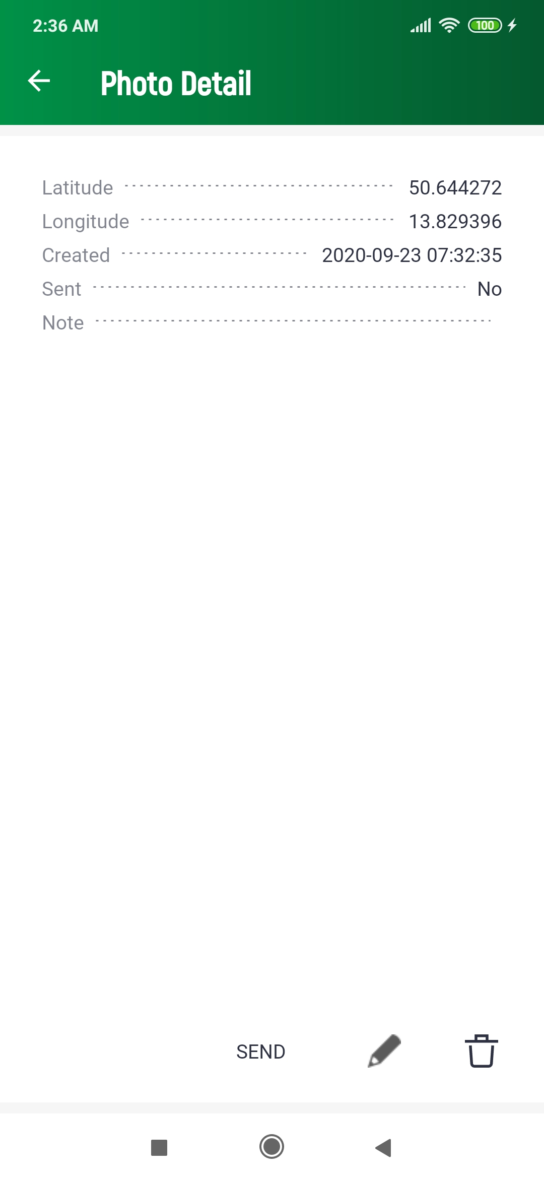 opens a dialog for editing a note on a specific photo.
*  deletes the displayed photo.
* *SEND* button uploads the displayed photo to the server.

After sending, the photo becomes non-editable. If an error occurs during uploading, the photo will be set to locked mode. The same rules apply to this mode as for submitting a task.

### Camera Mode

A camera screen interface is used to take a single photo or a photo for a task (Fig. 10).

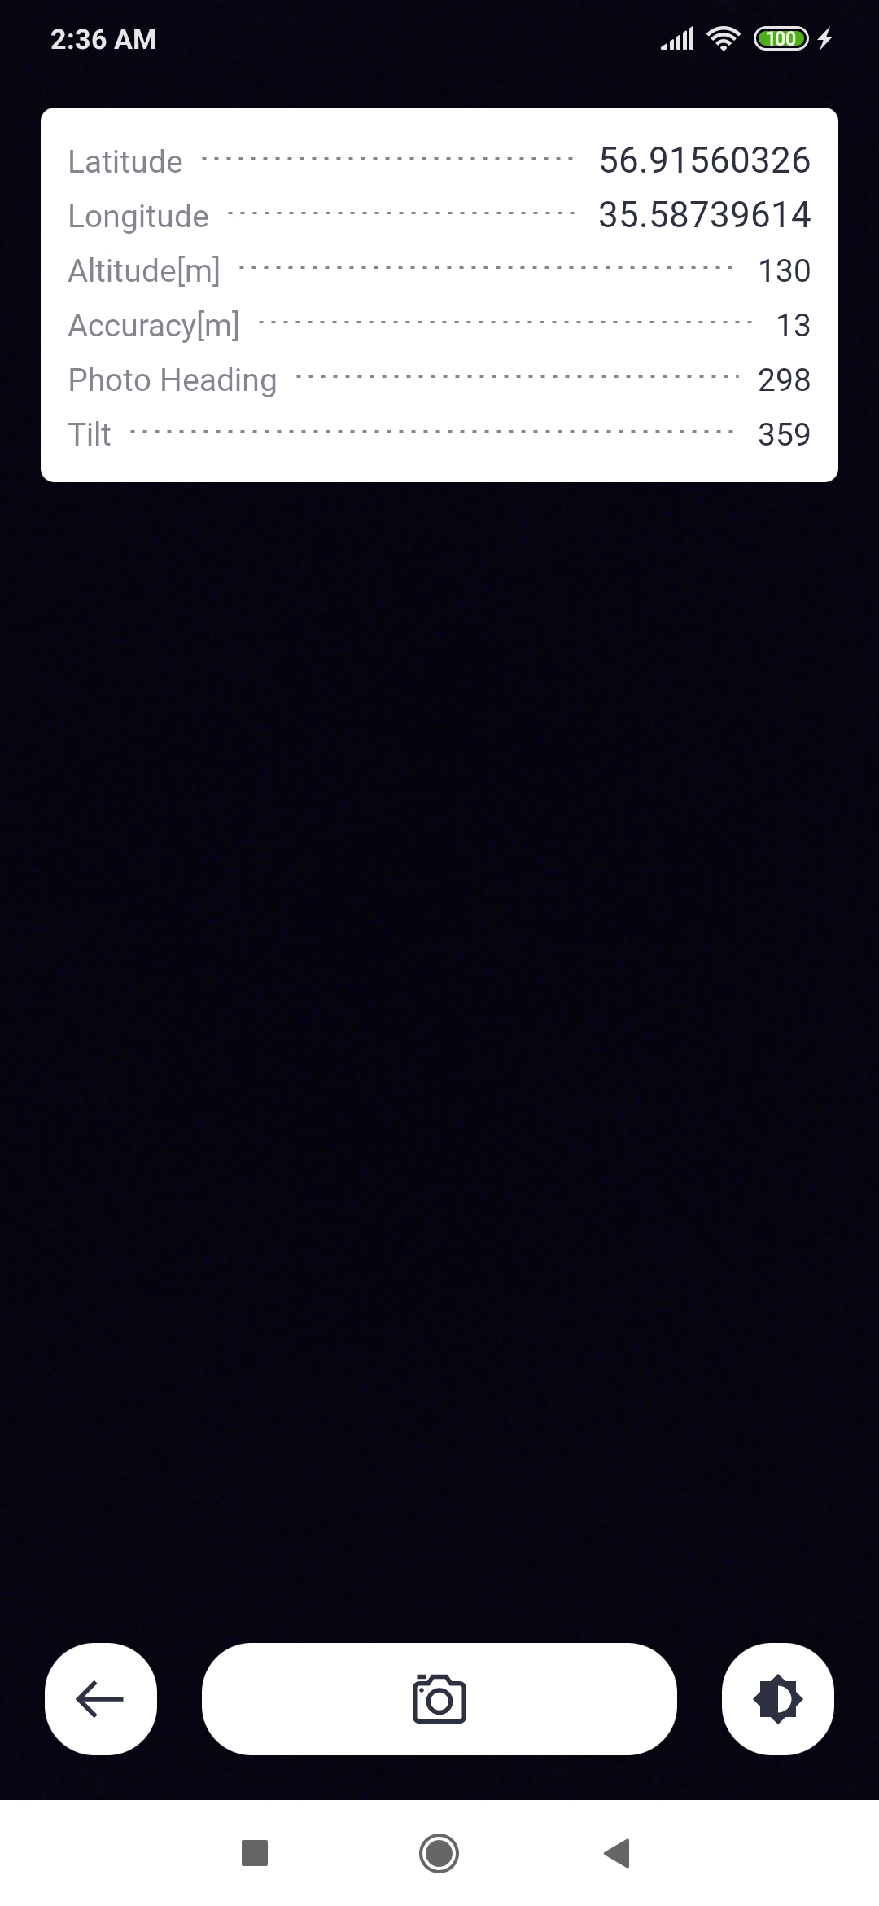

Fig. 10 Camera mode screen

The basic location data is displayed in the upper left corner:

* *Latitude* indicates the latitude in degrees.
* *Longitude* indicates longitude in degrees.
* *Altitude* indicates the height above the reference surface of the WGS 84 ellipsoid.
* *Accuracy* is an estimate of horizontal accuracy as the radius of reliability.
* Image *azimuth* indicates the azimuth of the horizon the camera captures.
* The *angle* expresses, in degrees, the tilt of the vertical axis of the screen to project on the horizontal surface of the earth.

If shooting with *position center of gravity* calculation is enabled in the settings, a window with data on the currently calculated position center of gravity is also displayed:

* *Latitude* indicates the latitude of the center of gravity in degrees.
* *Longitude* indicates the longitude of the center of gravity in degrees.
* *Samples* indicates the current number of processed samples to the total number specified in the application settings.

If manual brightness correction is enabled in the settings, this button is available . Click this button to display a slider to adjust the darkening or lightening of the image, as needed. The setting of this correction is retained even after the application is closed. Clicking in the middle area of this bar resets the brightness lock. If the camera does not respond to a change in brightness and the image is too dark or too bright, the camera hardware is not compatible with this application. In this case, it may help to turn off manual correction in the application settings (*Settings*).

The camera supports both portrait and landscape shooting.

The photo is taken by tapping the camera button , or by pressing the hardware button on the device defined in the application settings (*Settings*). Then the auto shutter will release with a countdown of approximately 5 seconds. The following conditions must be met to take a photo:

* The device must have a sufficiently good reception of location data.
* The user must not move and must stand still.

In addition, if center-of-gravity photography is permitted:

* The center of gravity of the position must already be calculated or a predetermined number of samples must be collected for its calculation.

If any of these conditions are not met, a warning message will be displayed, shooting will not be enabled and the shooting button will not be available. If any of these conditions are violated during auto shutter release, the image will also be rejected.

Click the button  to close the Camera mode and return to the previous screen.

Each time a photo is taken, the position calculated based on the extended Kalman filter (EKF) algorithm is also stored in the metadata of the photo. The position of the receiver is calculated in iterations. Each iteration consists of the following steps:

1. Pseudorange calculation
2. Download current satellite ephemeris from the web
3. Satellite position calculation
4. Receiver position calculation (EKF)

These types of satellite constellations are supported:

* GPS L1
* GPS L5
* GPS Ionosphere Free (L1/L5)
* Galileo E1
* Galileo E5a
* Galileo Ionosphere Free (E1/E5a)

The position data (PVT) of receiver from the most recent iteration is then stored in the metadata of the captured photo. The PVT data are evaluated simultaneously (in parallel) for each type of constellation. PVT data contains the following attributes:

* Latitude
* Longitude
* Altitude
* Reference time

To satisfy point number 2 in each iteration, the device must be connected to the Internet at the time of the calculation, otherwise the calculation cannot be performed.

When calculating the position of the satellite, the tropospheric and Shapiro correction is included in the calculation for each GNSS constellation. For GPS, ionospheric correction based on Klobuchar’s algorithm is also included.

### Map

The map is divided into two modes, one (photo mode) showing a group of photos of the logged in user (from sets of individual photos or photos within tasks), the other (path tracking mode) shows the currently recorded or already recorded paths.

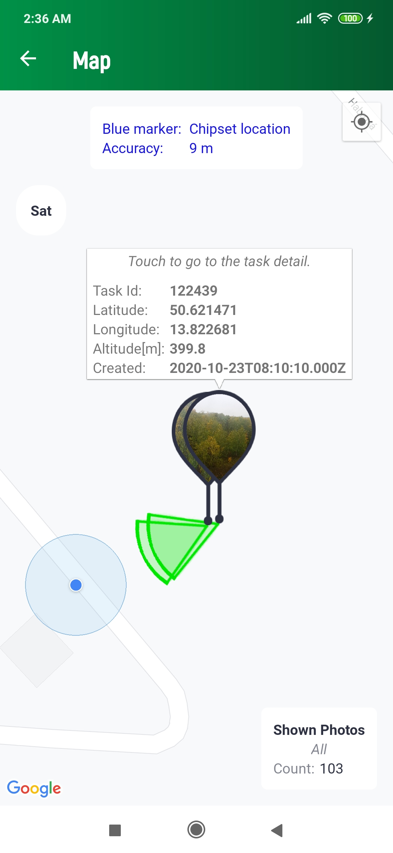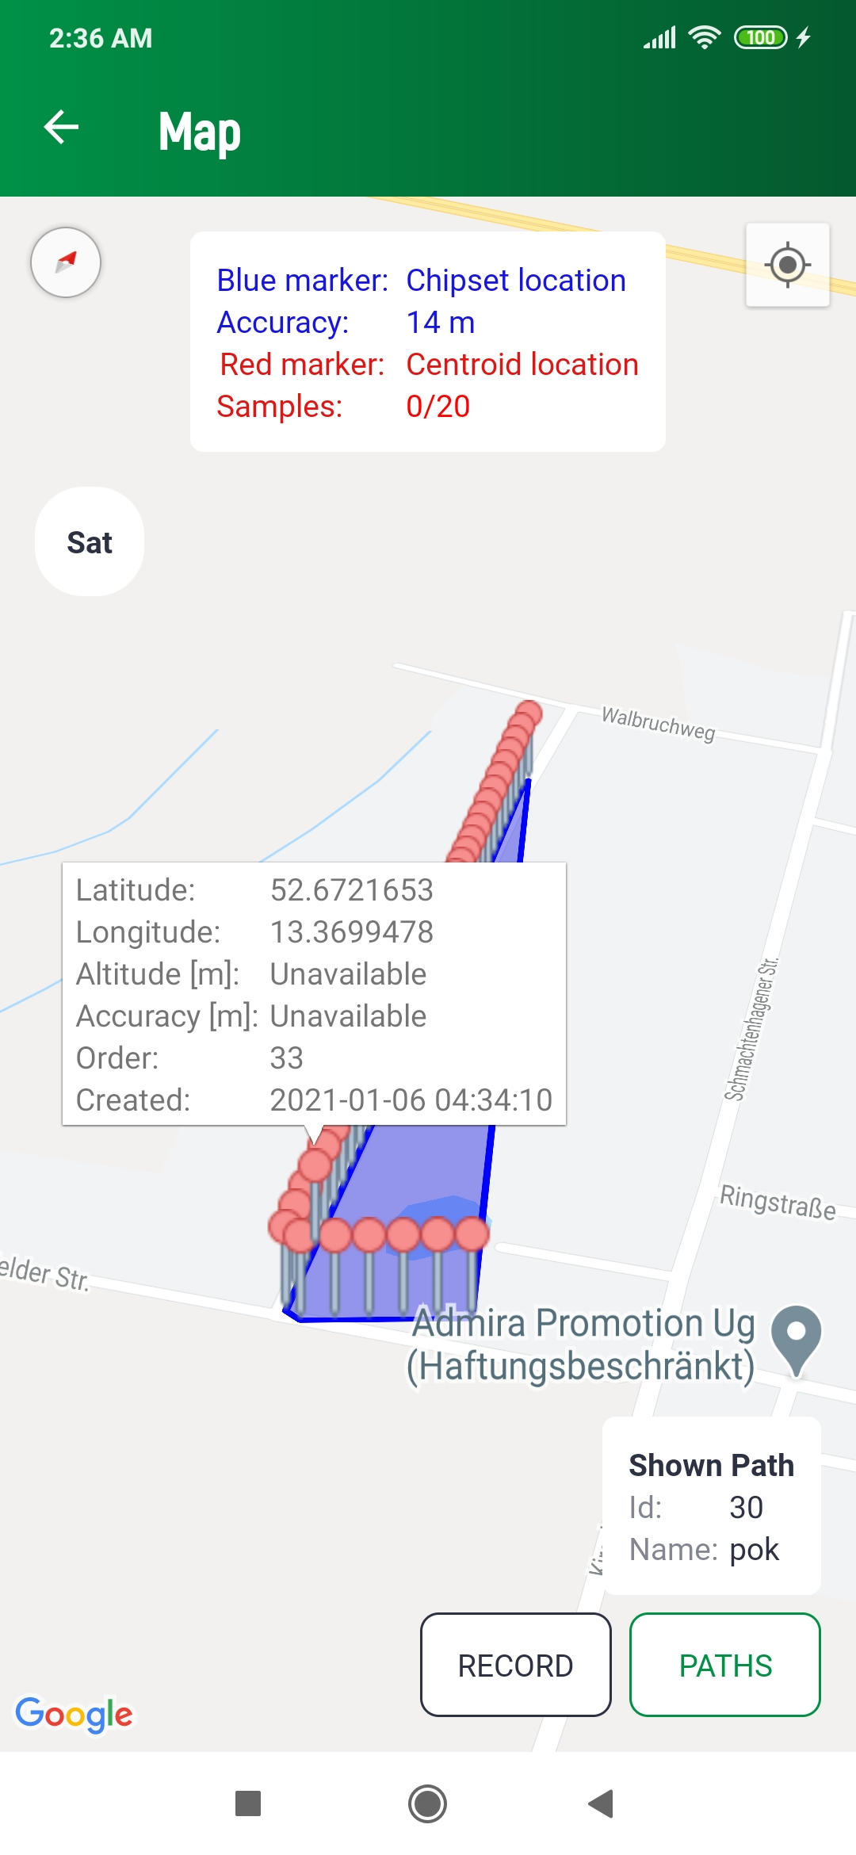

Fig. 11 The map photos and tracked paths

If location data is available, the current position will be marked on the map in the form of a blue dot 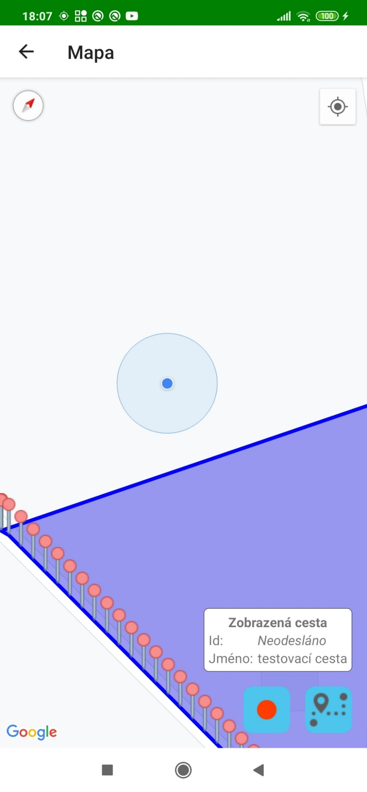, which can be navigated on the map by tapping the button 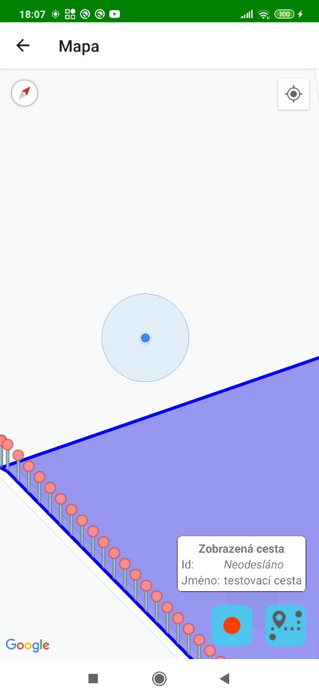.

Button 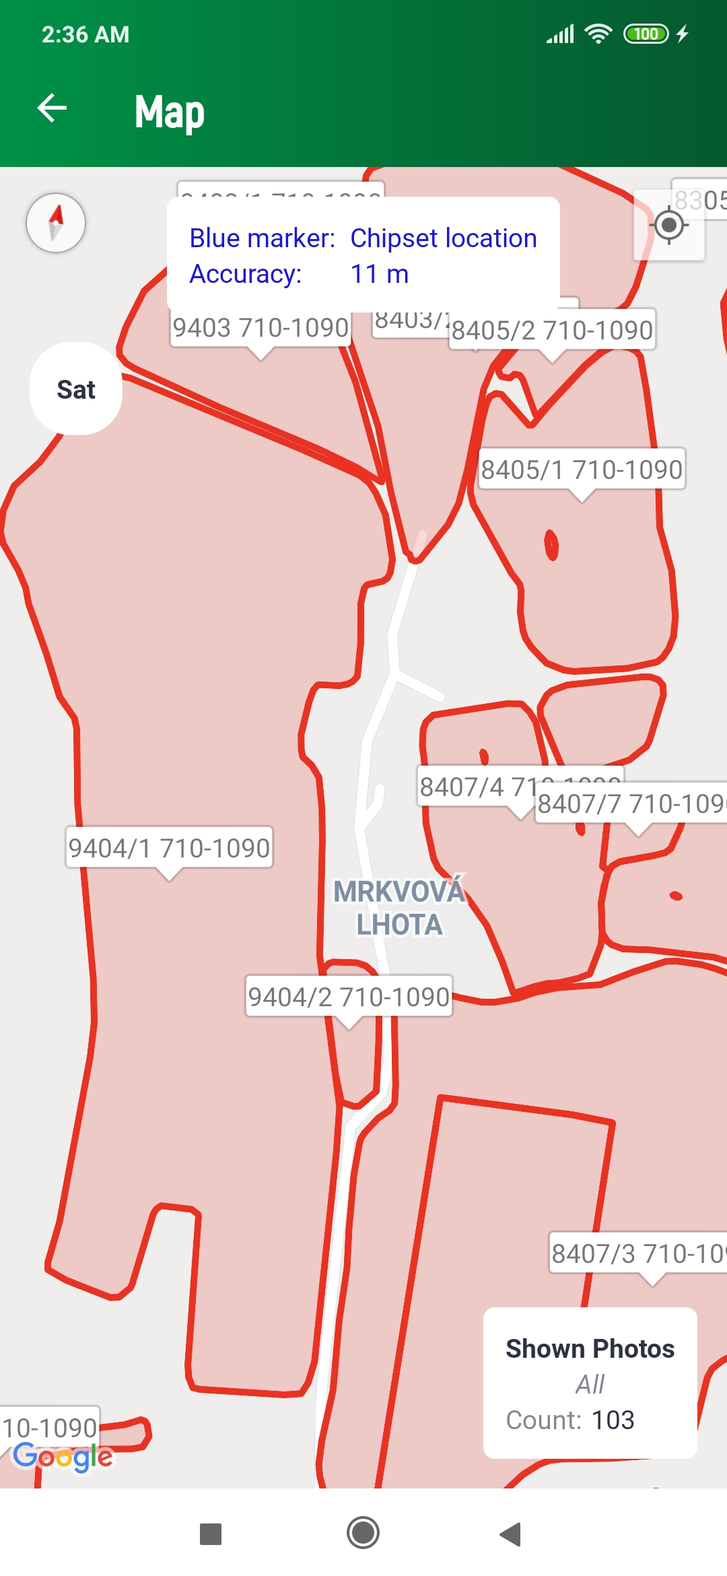 / 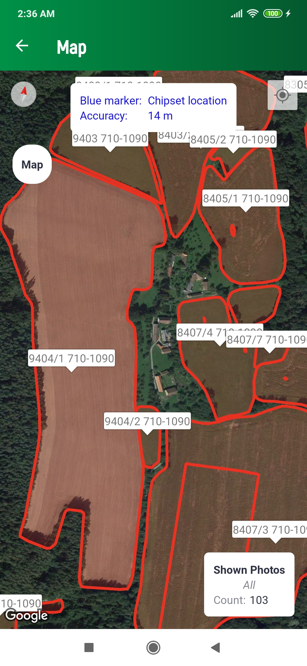 switches the map view to a satellite or a map view.

With a sufficiently large zoom above the map in both modes, plots with their identifiers will begin to appear as red polygons. This LPIS rendering is currently only possible for the territory of the Czech Republic, and depends on the availability of LPIS data per EU Member State.



Fig. 12 Map with parcels displayed

There is a black dot in the photo mode of the map at the location where the image was taken, with a small icon above it. The green circle determines the azimuth direction of the mobile device's screen at the time the photo was taken. Press the image icon to display an overview of the basic attributes of the image. If it is a photo within a task, pressing this report will take the user to the detail of the task to which the image belongs. (Fig. 13). In the photo mode of the map, a window with information about the type of displayed photos and their total number is displayed in the lower right corner. Clicking in this report will move the map view to all these photos.

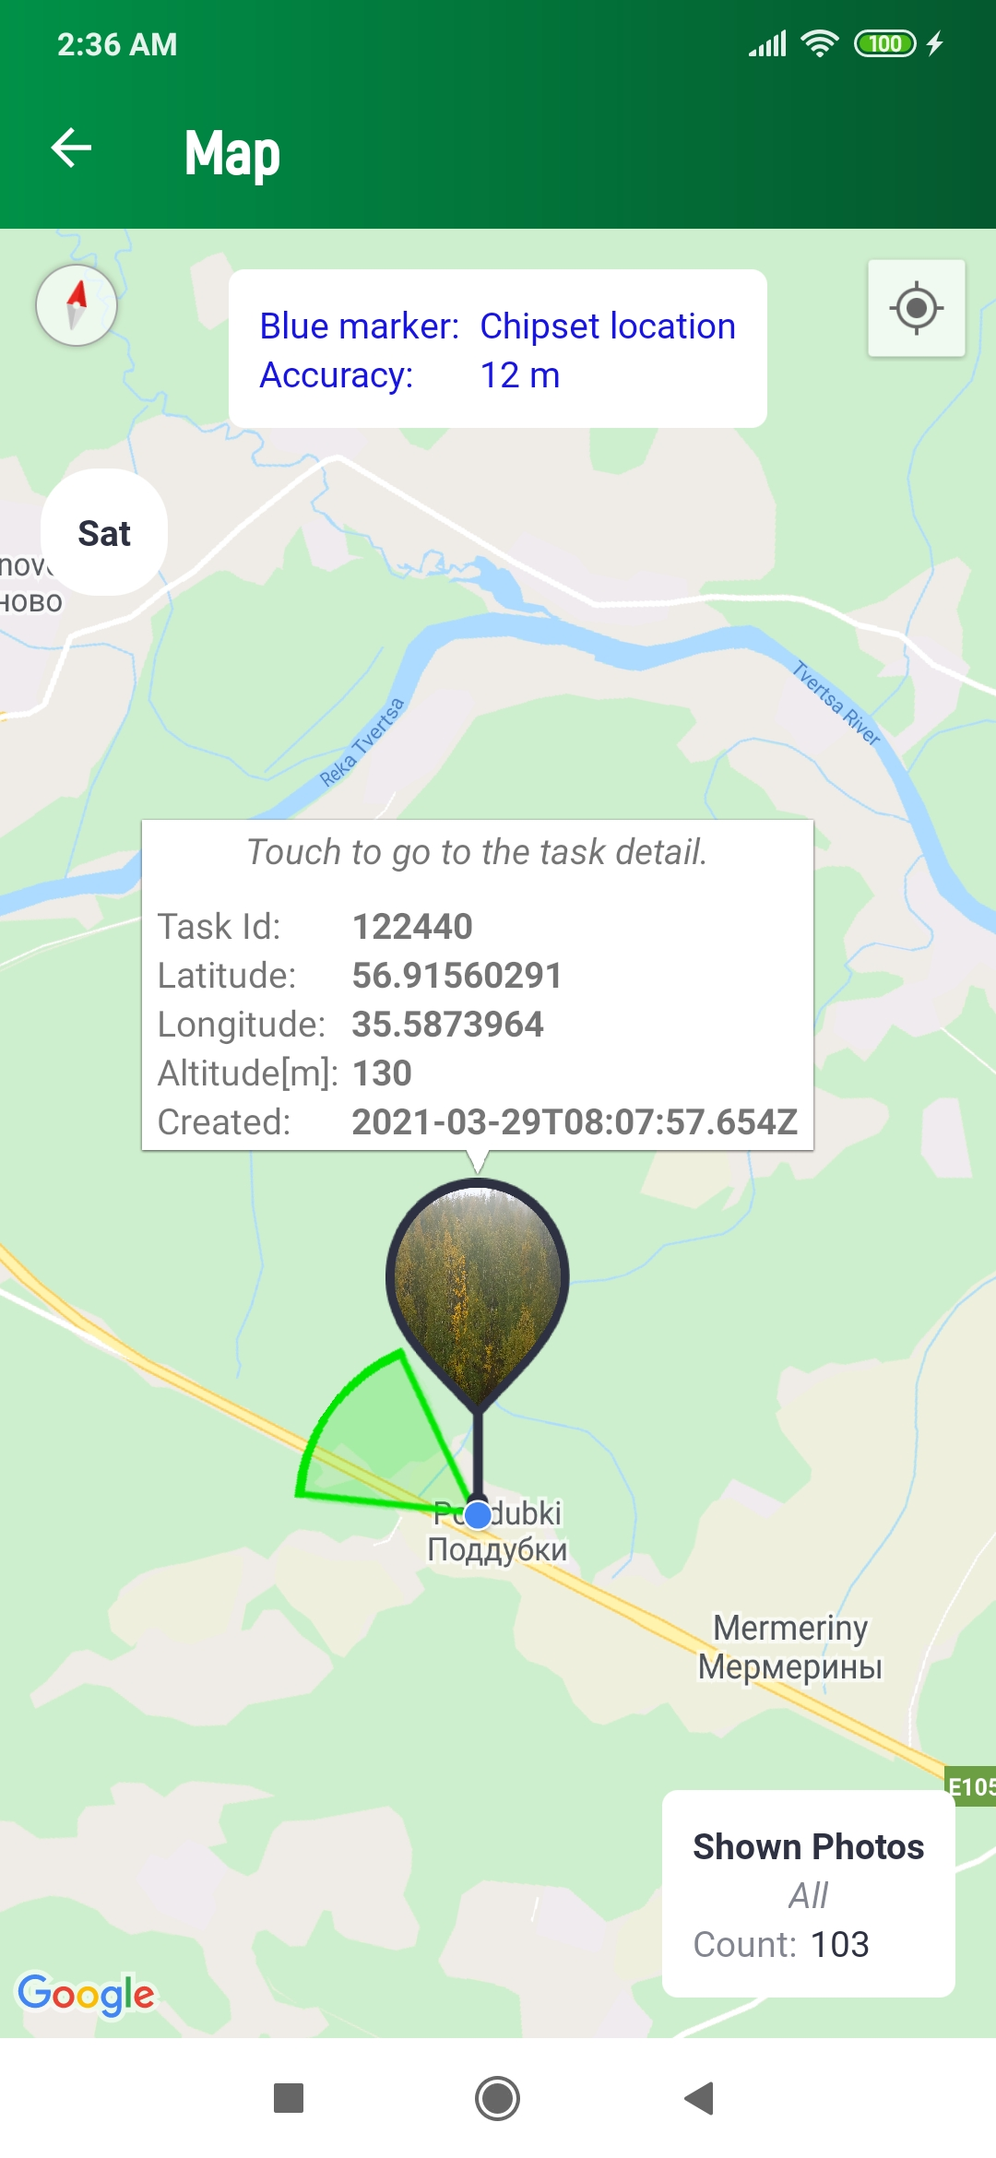

Fig. 13 Preview of the photo on the map

If the map is in path tracking mode, the current position calculated from GNSS as the center of gravity of the positions is also displayed. This location is indicated by a red dot 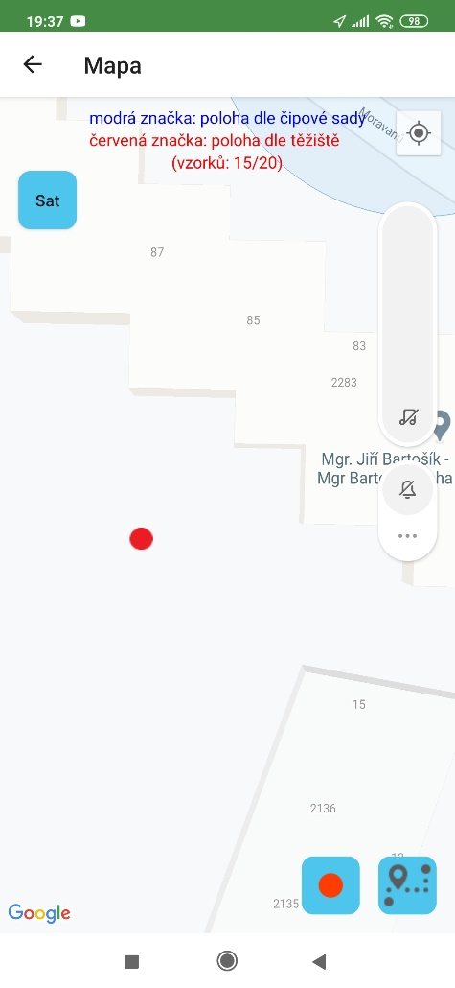. This position is always updated after the collection of all samples necessary for the calculation of the center of gravity, the number of which is defined in the application settings (*Settings*) by the parameter *Number of samples for the center of gravity*. Samples for calculating this position are taken from GGA sentences from NMEA messages from navigation satellites. Let these individual samples be denoted as $p_{i}$. The calculation is performed as follows:

The centroid $c$ of the set $S⊂R^{2}$ consisting of all defined points $p_{i}∈S, i∈\left\{1,2, …, n\right\}$ is computed as the average of the points

$$\sum_{p_{i}∈C{}_{m}}{\frac{p_{i}}{\#C_{m}}}$$ where $C_{m}⊂S$ is the *innermost convex hull* of set $S$. The innermost convex hull is computed based on following definition:

Let the set $C_{1}$ be a convex hull of the original set $S_{0}=S$. Then the recursive relation

$$S_{1}=S_{0}\backslash C_{1}$$ $C_{i}$ is convex hull of $S_{i-1}$ $$S_{i}=S_{i-1}\backslash C_{i}$$

can be defined ($i∈N$). Since finally many points in the set $S_{0}$ are defined, there exists finally one $S_{m}=∅∧S_{i}≠∅$ for $∀i<m$. Then $C_{m}$ is the innermost convex hull of the set $S$.

In the path tracking mode of the map, you can record a path in the map view. Click the *RECORD* button, the dialog opens for entering a path name, which is optional. When this dialog is confirmed, the path will be recorded. The user can switch the application screens at will when recording the path, but the application must remain active and in the forefront of Android processes. The path is recorded in the form of points, between which there is an approximate recording interval of 1 second. When recording, the path is simultaneously drawn on the map in the form of a black linearly angled curve. Each point on the curve is represented by a pin icon 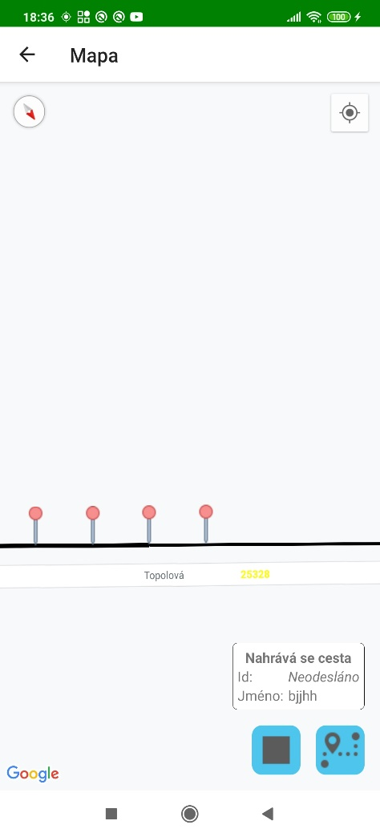 . When you click on it, an overview of its geolocation data is displayed. Use the PAUSE / UNPAUSE button to pause a path recording. Click the STOP button and then confirm the dialog box to end the recording. The path is then drawn as a polygon, where the first and last points of the path are connected. You can send the path to the server by clicking on SEND button. Click the *PATHS* button to go to the list of already recorded paths (*Paths*), where you can select a path to draw it on the map. Fields *id* and *name* of the drawn path on the map (currently recorded or already recorded) are displayed in the overview next to the buttons for recording the route. Clicking in this report will move the map view to this path. In the application settings, you can turn on a sound tone when recording a path point and automatically pan the map view to the current location during recording.

### Paths

This list shows all recorded routes (Fig. 14). Clicking on a specific road will draw it on the map (M). Each path already sent to the server is assigned its ID (*identification number*). If the route has not yet been sent, it can be deleted by clicking on the button . Click on the SEND button to send all paths which has not been sent yet.

* The *Area* attribute is an approximation of the area of a polygon formed by a path in square meters.
* The *By the center of gravity* attribute determines whether waypoints were taken as the center of gravity of the positions.

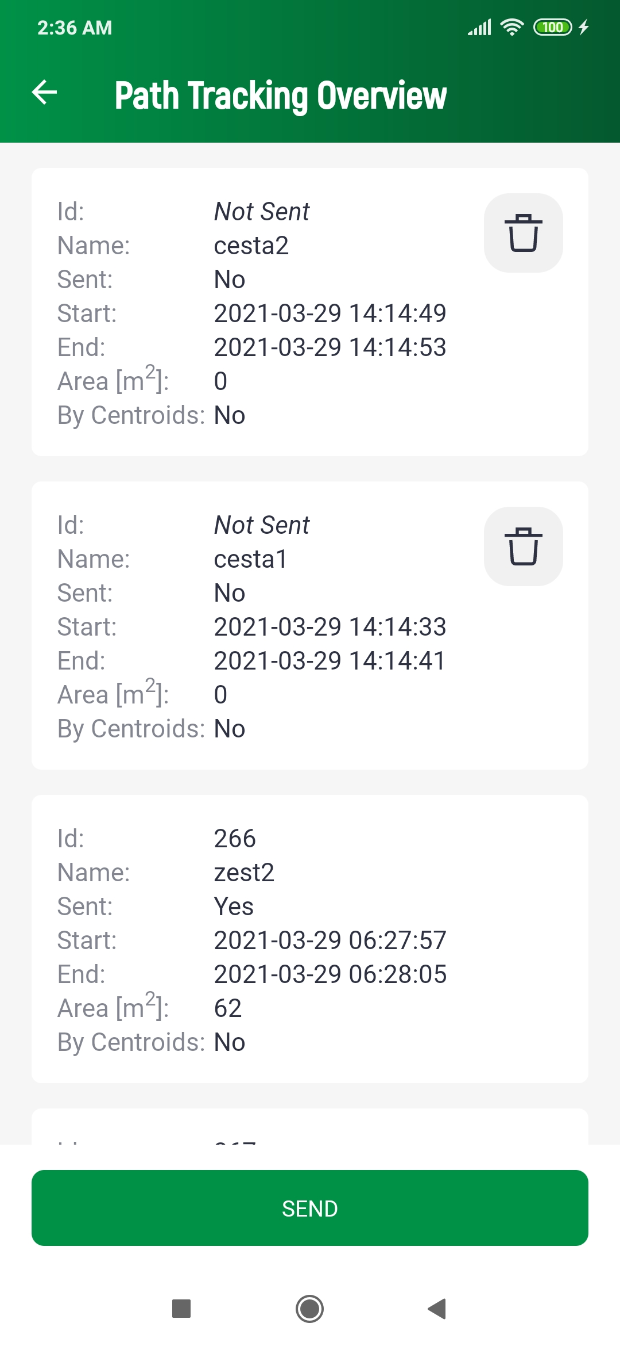

Fig. 14 Recorded paths list

### GNSS Raw Data

In this screen (Fig. 15) the user sees the current raw GNSS data received from the satellites with a basic overview of the device, the same as on the main screen (M). Most of the data is obtained from NMEA message records.

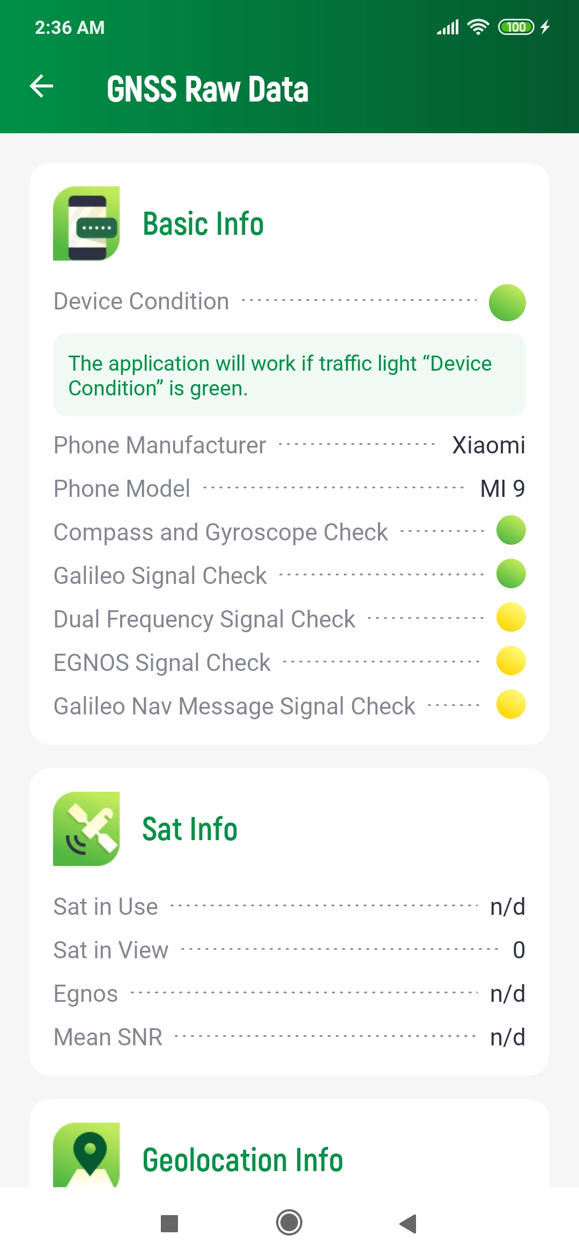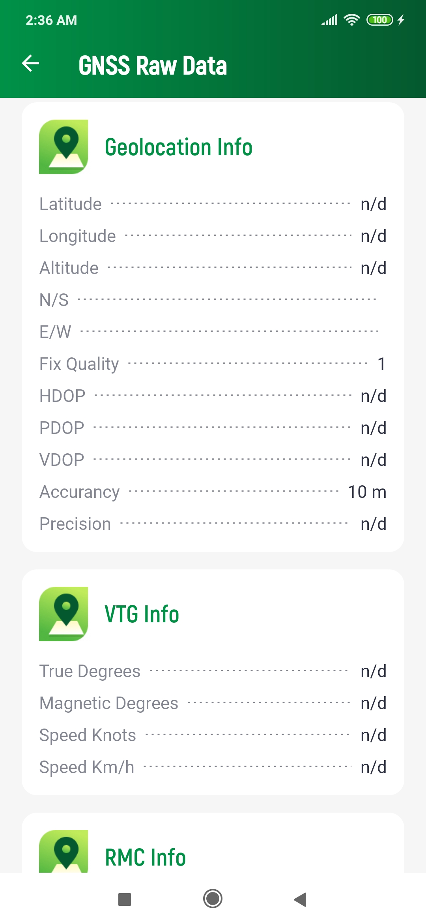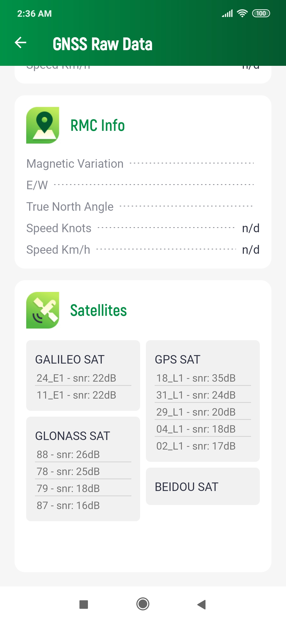

Fig. 15 GNSS Raw Data

* *Used satellites*
  + Number of satellites used
* *Satellites visible*
  + Number of visible satellites sending the SNR.
* *EGNOS*
  + Marked positive if the GPS Quality indicator value of the GGA sentence is equal to 2, marked negative if it is equal to 1, and marked as undecided in other cases.
* *Geolocation information*
  + The *Latitude*, *Elevation*, *Altitude*, *N / S*, and *E / W* attributes are taken from the GSA sentences.
  + The attributes *HDOP, PDOP, VDOP*, and *Quality Assessment* are taken from the GSA sentence.
  + The *Accuracy* attribute is an estimate of horizontal accuracy as the radius of 68% reliability. It is obtained from the location service.
  + The *Accuracy* in meters attribute is calculated above the center of gravity of the position. The calculation parameters are defined by the application settings.
* *VTG info*
  + All attributes are read from the VTG sentence.
* *RMC Info*
  + All attributes are read from the RMC sentence.
* *SNR*
  + *Mean SNR of the last detected satellites.*
* List of satellites
  + *GALILEO SATs*, *GPS SATs*, *GLONASS SATs*, *BEIDOU SATs* display satellites sending the SNR.

## About

This screen contains basic information about the application (Fig. 16).

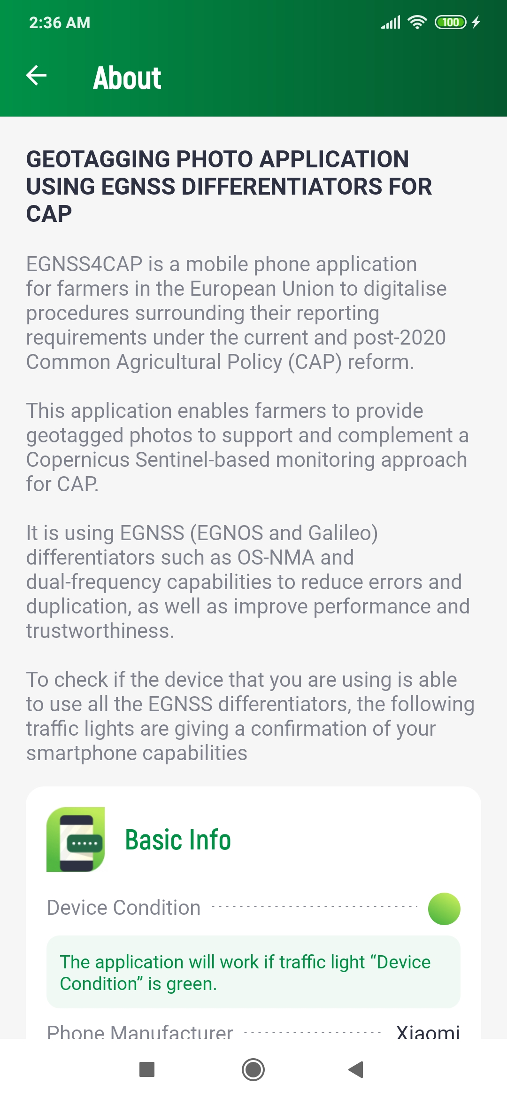

Fig. 16 About screen

## Settings

The screen provides the main settings of the entire application (Fig. 17).

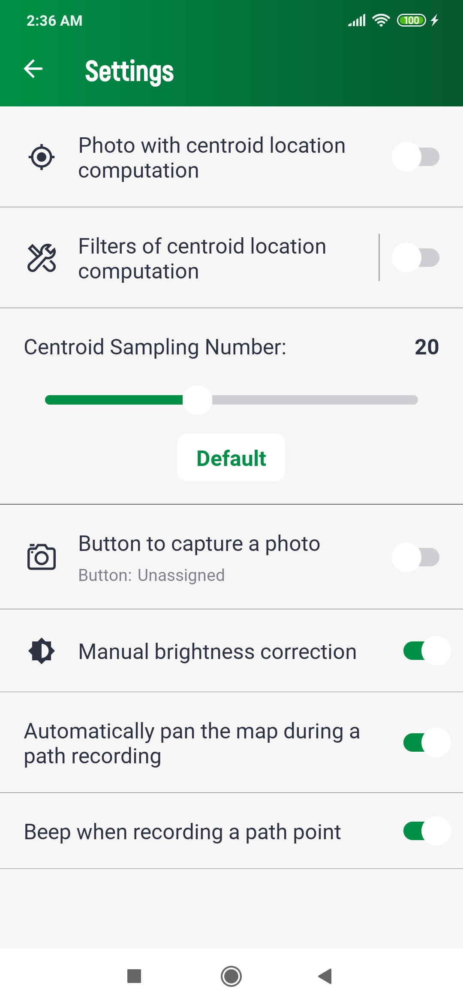

Fig. 17 Settings

* *Shooting with the calculation of the center of gravity of positions* 
  + When capturing an image, location center of gravity information will be added to its metadata.
* *Position center of gravity calculation filters* 
  + Activates filters above the samples when calculating the position center of gravity. After clicking in the right area of this item, you will go to the settings of these filters (Fig. 18).
* *Number of samples for the center of gravity* 
  + Sets the number of samples required to calculate the position center of gravity.
  + Click the *Default* button to set the default number.
* *Button to take a photo* 
  + Defines a hardware button for taking a photo in camera mode (C).
  + If activated, the dialog for setting the hardware button on the device is displayed. The setting is made by pressing the desired button when this dialog is displayed.
  + Not all buttons on the device are suitable or usable. E.g. suitable buttons are for volume control. E.g. the screen lock button cannot be used.
* *Manual brightness correction*
  + Activates the manual brightness correction option in camera mode (C).
* *Automatically pan the map during a path recording*
  + Automatically focus the map view to your current location while recording a path (M).
* *Beep when recording a path point*
  + Emits a tone each time a point is recorded while recording a path (M).

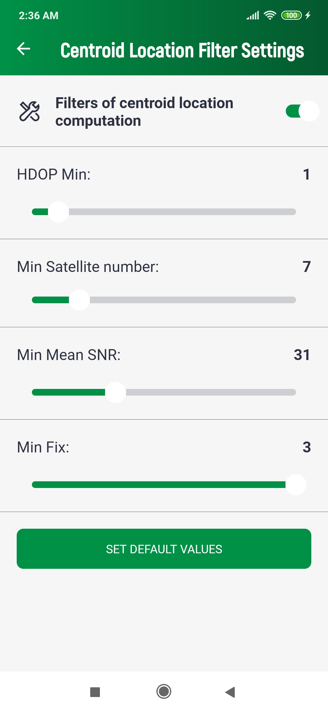

Fig. 18 Position center of gravity calculation filters

The position center of gravity filters (Fig. 18) for each sample received decide whether or not to include it in the center of gravity calculation.

* Min HDOP
  + the HDOP value greater than or equal to a defined value.
* Min. number of satellites
  + The data comes from a greater or equal defined number.
* Min. mean h. SNR
  + The minimum mean SNR value of the satellites used is greater than or equal to the defined value.
* Min. fix
  + The value of the Fix type (according to the GSA record) is greater than or equal to the defined value.

Clicking the *SET DEFAULT VALUES* button returns all filter values to the default.

# Mobile Application - iOS

## Installation

### Installation from App Store or via TestFlight

The application is currently available only via TestFlight. Registration as a tester is needed.

### Compiling from source code

The source code and the directory structure are compatible and meet the requirements for the xcode in which it was created.

### Minimal requirements

* iOS 13 compatible iPhone or iPad or newer (iPhone 6S/SE or newer)

## Application Start and Permissions

The application can be run by selecting it in the list of applications.

* Make sure to grant permissions to access the device’s location and take pictures:
  + Access device’s location
    - Allow to add location data to token photos.
    - Receiving different types of location data
    - Recording paths.
  + Take pictures and record video
    - Allow to take photos by camera.

To log in to the application, connection to the internet is required. After the first login, the user will be remembered. A new login will only be required after explicit logout.

### Login

After the first launch of the application and granting all the necessary permissions to the application, the user will be presented with a login screen (Fig. 3), where the assigned login and password will need to be filled out. Click the *Sign In* button to complete the login.

To successfully log in, all data most be entered correctly and the device should be connected to the Internet at the time of login. The login details will be remembered for future uses of the app. Re-login will be required only after explicit logout of the user.

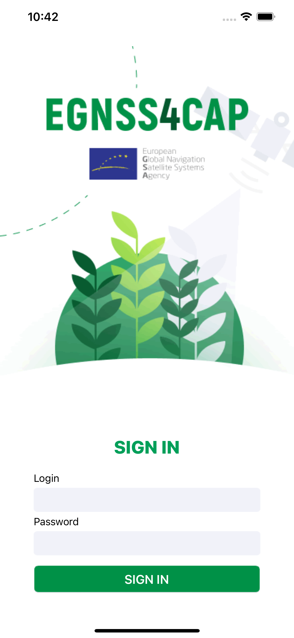

Fig. 19 Login screen

## Main Screen

The attributes of the host device are displayed in the “Basic Info” section. Traffic lights are displayed next to some of the attributes. Their detailed description is given below.

* Location service check
  + The green color indicates the active ability of the phone to determine its current location.
  + Red means an inability to determine your current position. If this is the case, location services on the device may be disabled.

Other attributes use the green or yellow color.

Green indicates that the device has that particular property. Yellow indicates that the device does not have the given property or has not yet been able to verify the given availability and may change to green over time.

* Galileo capability
  + Checks if the device is capable to read Galileo signals

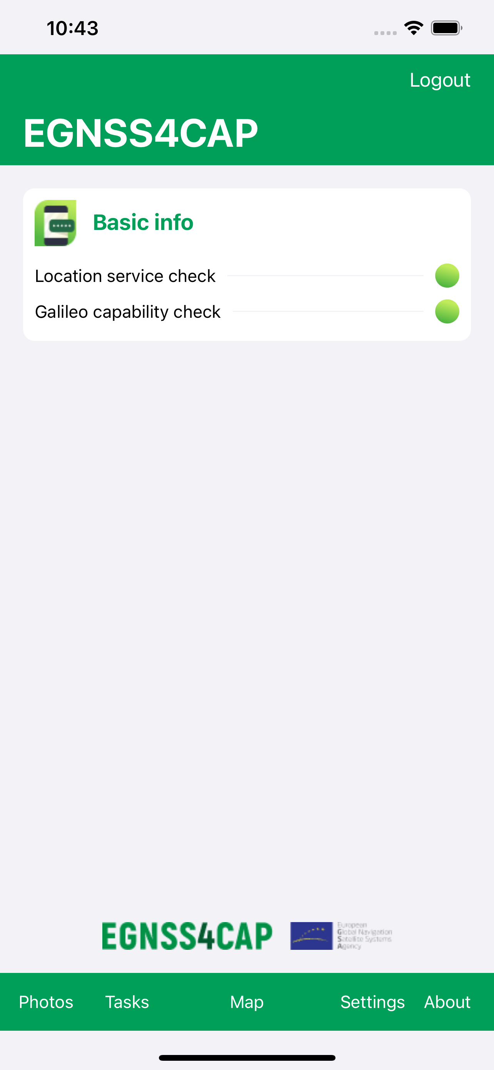

Fig. 20 Main screen

The application modules can be accessed through by pressing buttons which are situated in the bottom of the screen. The following options are available:

* Photos
  + Open screen with list of unowned photos.
* Tasks
  + Open screen with task list.
* Map
  + Open screen with map including all captured photos, recording new paths or viewing already recorded paths.
* Settings
  + Open screen with settings.
* About
  + Open screen with basic information about application

### Task List

In the task overview (Fig. 5), user tasks are listed by name, status, number of captured images, creation date and due date. By clicking on a specific task, a screen with details and options to edit is displayed.

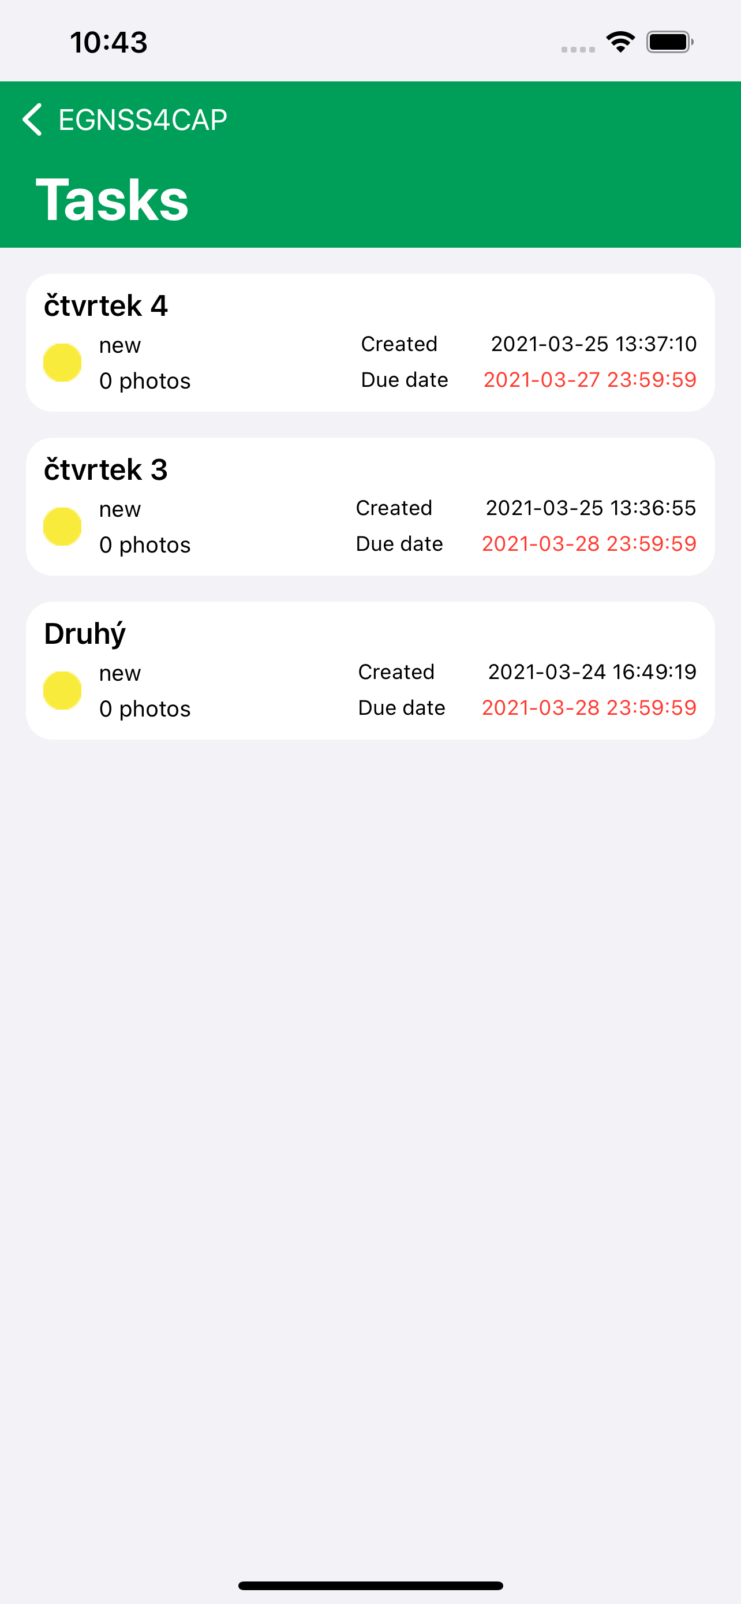

Fig. 5 Task list

Tasks can be set in following states, which also determine their editability:

|  |  |  |
| --- | --- | --- |
| Description | | Editable |
|  | **New** A new task | **YES** |
|  | **Open**  A new task, which has been already displayed by the user. The user is aware of the task. | **YES** |
|  | **Returned** The has been returned by the officer to the farmer with an additional information request. | **YES** |
|  | **Data provided**  The task which was completed and sent by the farmer to the PA | **NO** |

### Task detail

The task detail (Fig. 6) shows the data attributes of the task, including all captured images. Depending on the status of the task, the task can either be edited or viewed.

* The upper section lists the basic data attributes of the task.
* The *Instructions* section shows the description needed to complete the task given by an authorized staff member of the Paying Agency.
* The *Reason for return* section describes the reason for the Paying Agency why the task was returned for a new performance.
* The *Note* section is completed by the user as part of completing the task before it is submitted.
* The photo section shows thumbnails of photos taken. The user takes photos by clicking the button , which enters the camera mode for shooting (Camera Mode). Tap to delete the currently displayed photo .
* Use the buttons *Previous* and *Next* to move between photo previews.

A photo cannot be deleted if it has been already sent to the server, even if the task is in an editable state.

Click the *SEND* button to send the message. After successful submission, the task can no longer be edited.

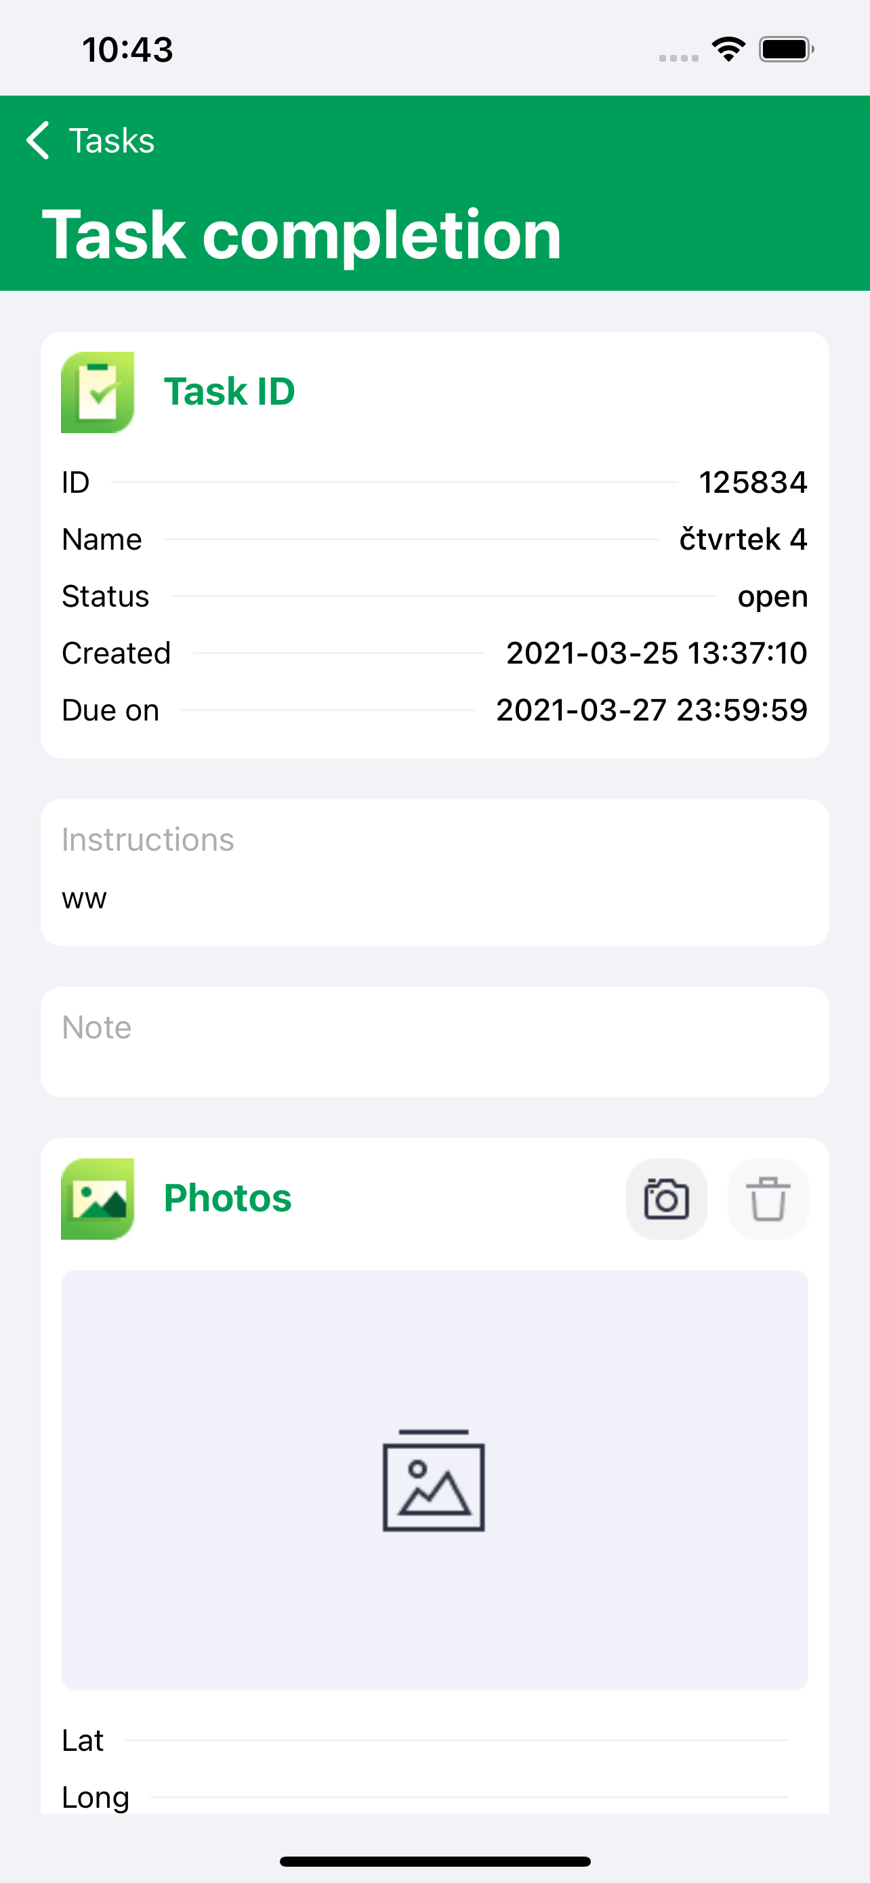

Fig. 6 Task edit

Clicking on the photo preview will open a window with its detail (Fig. 7). The basic attributes of the photo are displayed in the upper left corner. In this view, you can switch views between all photos of the task using the buttons  and .

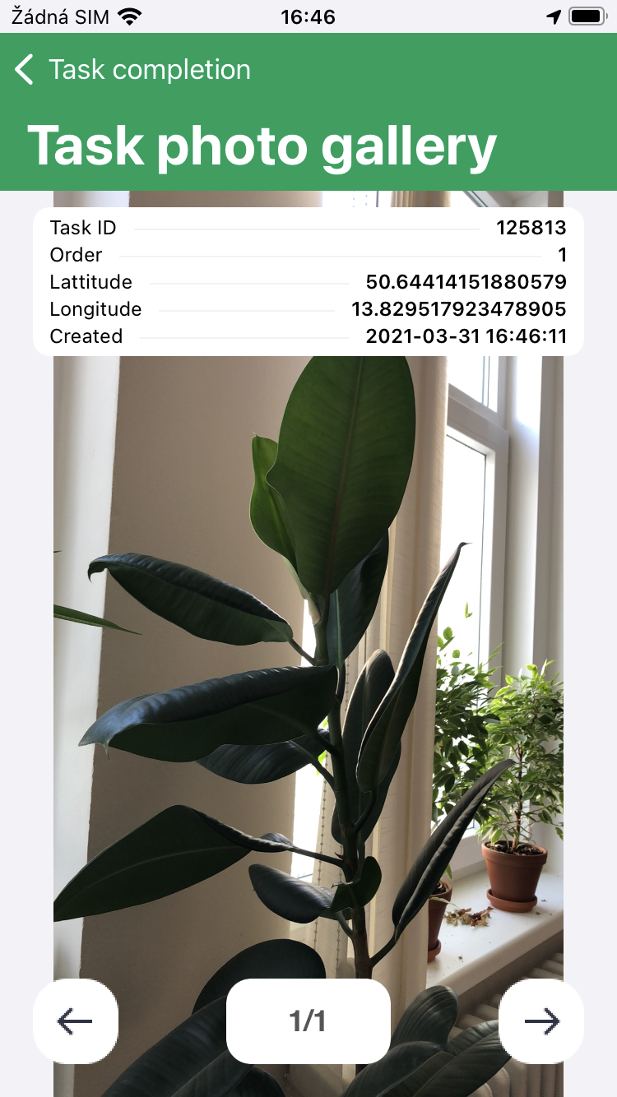

Fig. 7 Photo detail

### Standalone Snapshots

Screen showing photos in the list (Fig. 8) taken separately outside the task. In each list item, on the left is a preview of the photo and on the right a list of basic metadata.

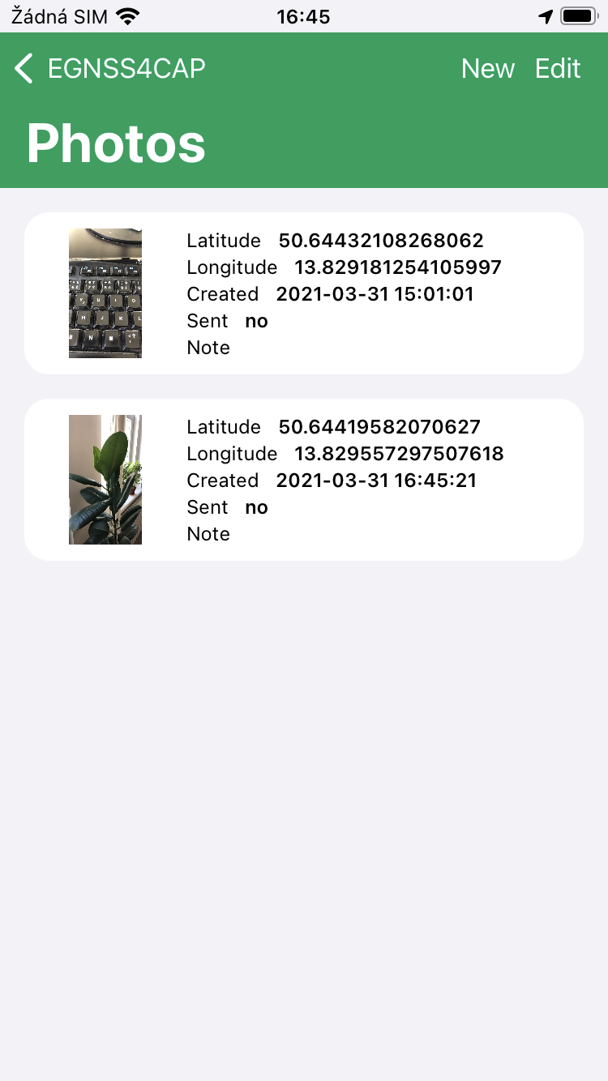

Fig. 8 Overview of standalone photos

From this screen, new photos are taken by touching of a button *NEW*, which enters the user to take camera mode (Camera Mode).

Clicking on a photo item in the list opens its detail (Fig. 9). Click the *SEND* button to send the photo to server.

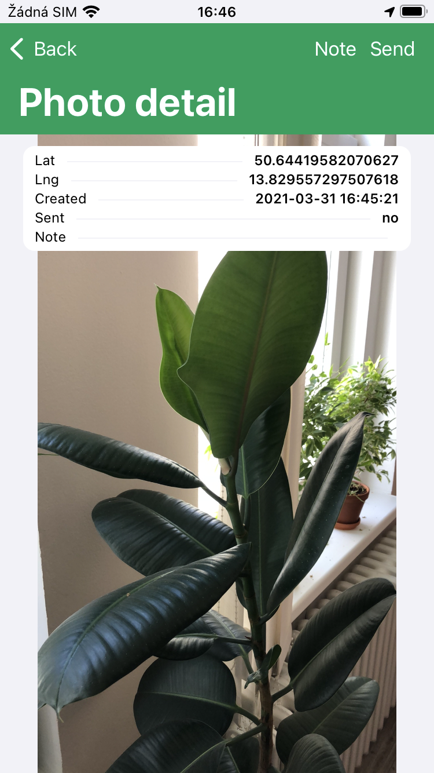

Fig. 9 Detail of a standalone photo

### Camera Mode

A camera screen interface is used to take a single photo or a photo for a task (Fig. 10).

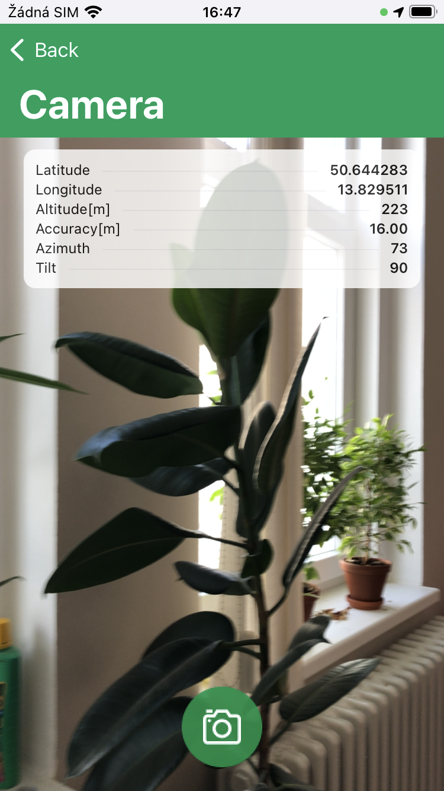

Fig. 10 Camera mode screen

The basic location data is displayed in the upper left corner:

* *Latitude* indicates the latitude in degrees.
* *Longitude* indicates longitude in degrees.
* *Altitude* indicates the height above the reference surface of the WGS 84 ellipsoid.
* *Accuracy* is an estimate of horizontal accuracy as the radius of reliability.
* Image *azimuth* indicates the azimuth of the horizon the camera captures.
* The *angle* expresses, in degrees, the tilt of the vertical axis of the screen to project on the horizontal surface of the earth.

If shooting with *position center of gravity* calculation is enabled in the settings, a window with data on the currently calculated position center of gravity is also displayed:

* *Latitude* indicates the latitude of the center of gravity in degrees.
* *Longitude* indicates the longitude of the center of gravity in degrees.
* *Samples* indicates the current number of processed samples to the total number specified in the application settings.

The camera supports both portrait and landscape shooting.

The photo is taken by tapping the camera button . Then the auto shutter will release with a countdown of approximately 5 seconds. The following conditions must be met to take a photo:

* The device must have a sufficiently good reception of location data.
* The user must not move and must stand still.

In addition, if center-of-gravity photography is permitted:

* The center of gravity of the position must already be calculated or a predetermined number of samples must be collected for its calculation.

If any of these conditions are not met, a warning message will be displayed, shooting will not be enabled and the shooting button will not be available. If any of these conditions are violated during auto shutter release, the image will also be rejected.

Click the button  to close the Camera mode and return to the previous screen.

## Map

The map is showing a group of photos of the logged in user (from sets of individual photos or photos within tasks and the currently recorded or already recorded paths.

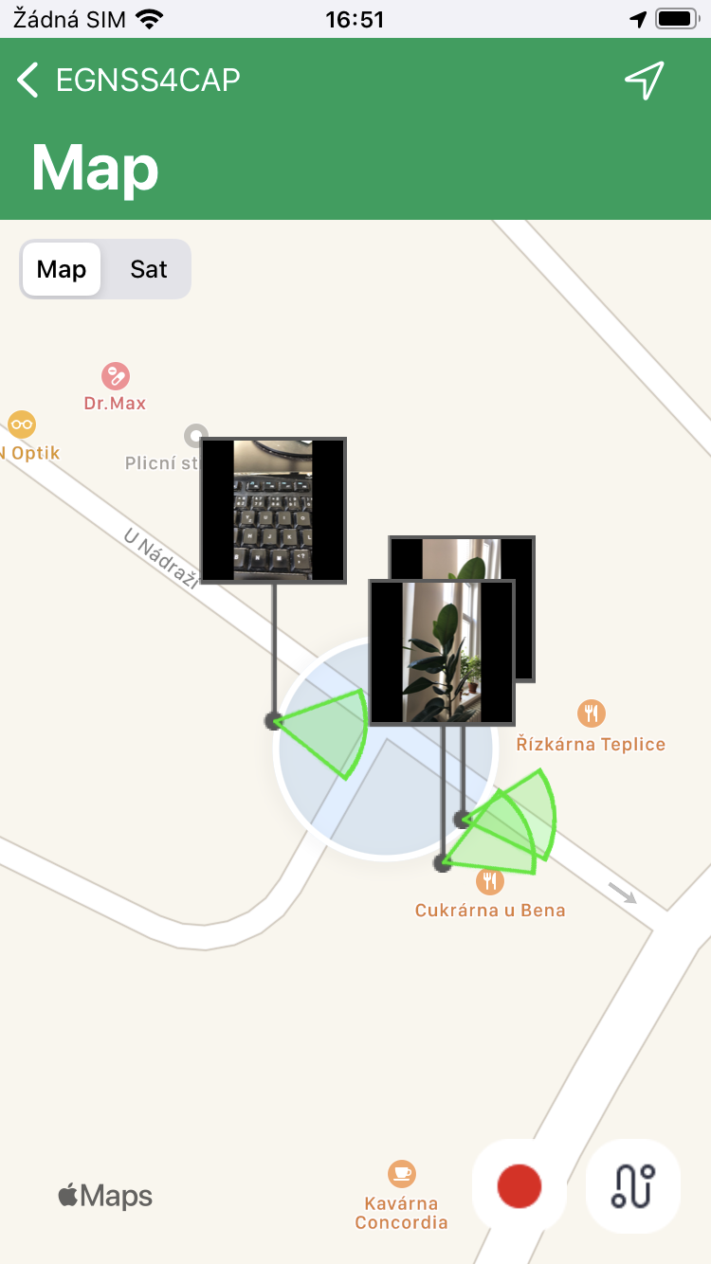

Fig. 11 The map photos and tracked paths

If location data is available, the current position will be marked on the map in the form of a blue dot . Button  /  switches the map view to a satellite or a map view.

There is a black dot in the photo mode of the map at the location where the image was taken, with a small icon above it. The green circle determines the azimuth direction of the mobile device's screen at the time the photo was taken. Press the image icon to display an overview of the basic attributes of the image.

You can record a path in the map view. Click the *RECORD* button, the dialog opens for entering a path name, which is optional. When this dialog is confirmed, the path will be recorded. The user can switch the application screens at will when recording the path, but the application must remain active. The path is recorded in the form of points, between which there is an approximate recording interval of 1 second. When recording, the path is simultaneously drawn on the map in the form of a black linearly angled curve. Each point on the curve is represented by a pin icon  . When you click on it, an overview of its geolocation data is displayed. Click the STOP button to end the recording. The path is then drawn as a polygon, where the first and last points of the path are connected. Click the *PATHS* button to go to the list of already recorded paths (*Paths*), where you can select a path to draw it on the map. Fields *id* and *name* of the drawn path on the map (currently recorded or already recorded) are displayed in the overview next to the buttons for recording the route. Clicking in this report will move the map view to this path. In the application settings, you can turn on a sound tone when recording a path point and automatically pan the map view to the current location during recording.

### Paths

This list shows all recorded routes (Fig. 14). Clicking on a specific road will draw it on the map (M). Click on the SEND button to send all paths which has not been sent yet.

* The *Area* attribute is an approximation of the area of a polygon formed by a path in square meters.

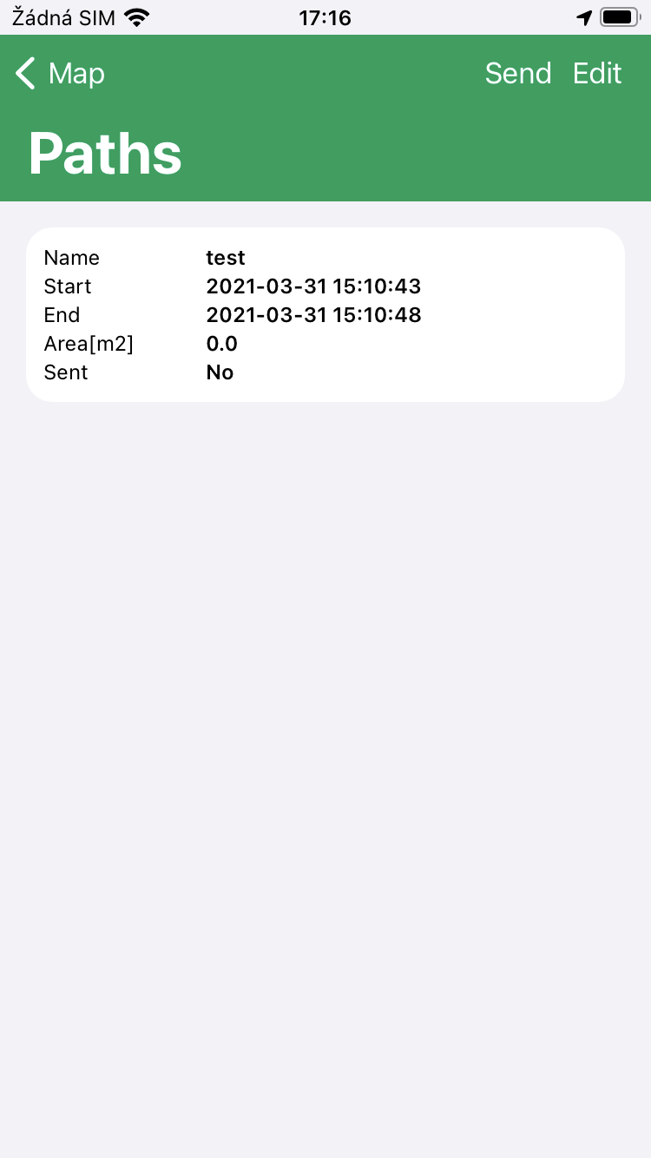

Fig. 14 Recorded paths list

## About

This screen contains basic information about the application (Fig. 16).

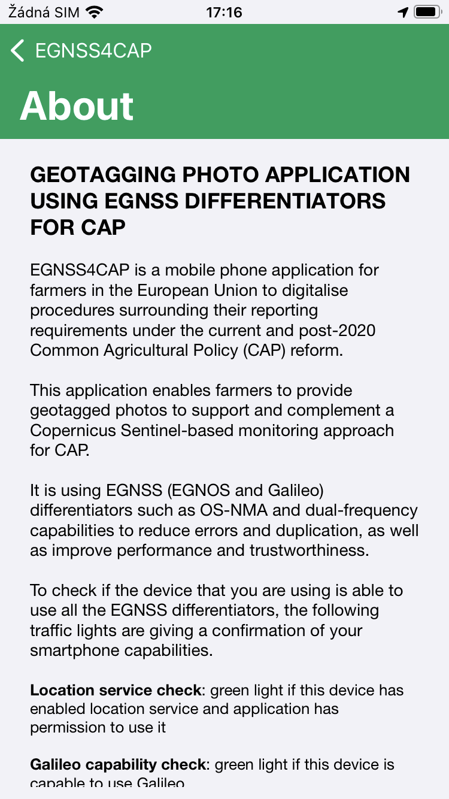

Fig. 16 About screen

## Settings

The screen provides the main settings of the entire application (Fig. 17).

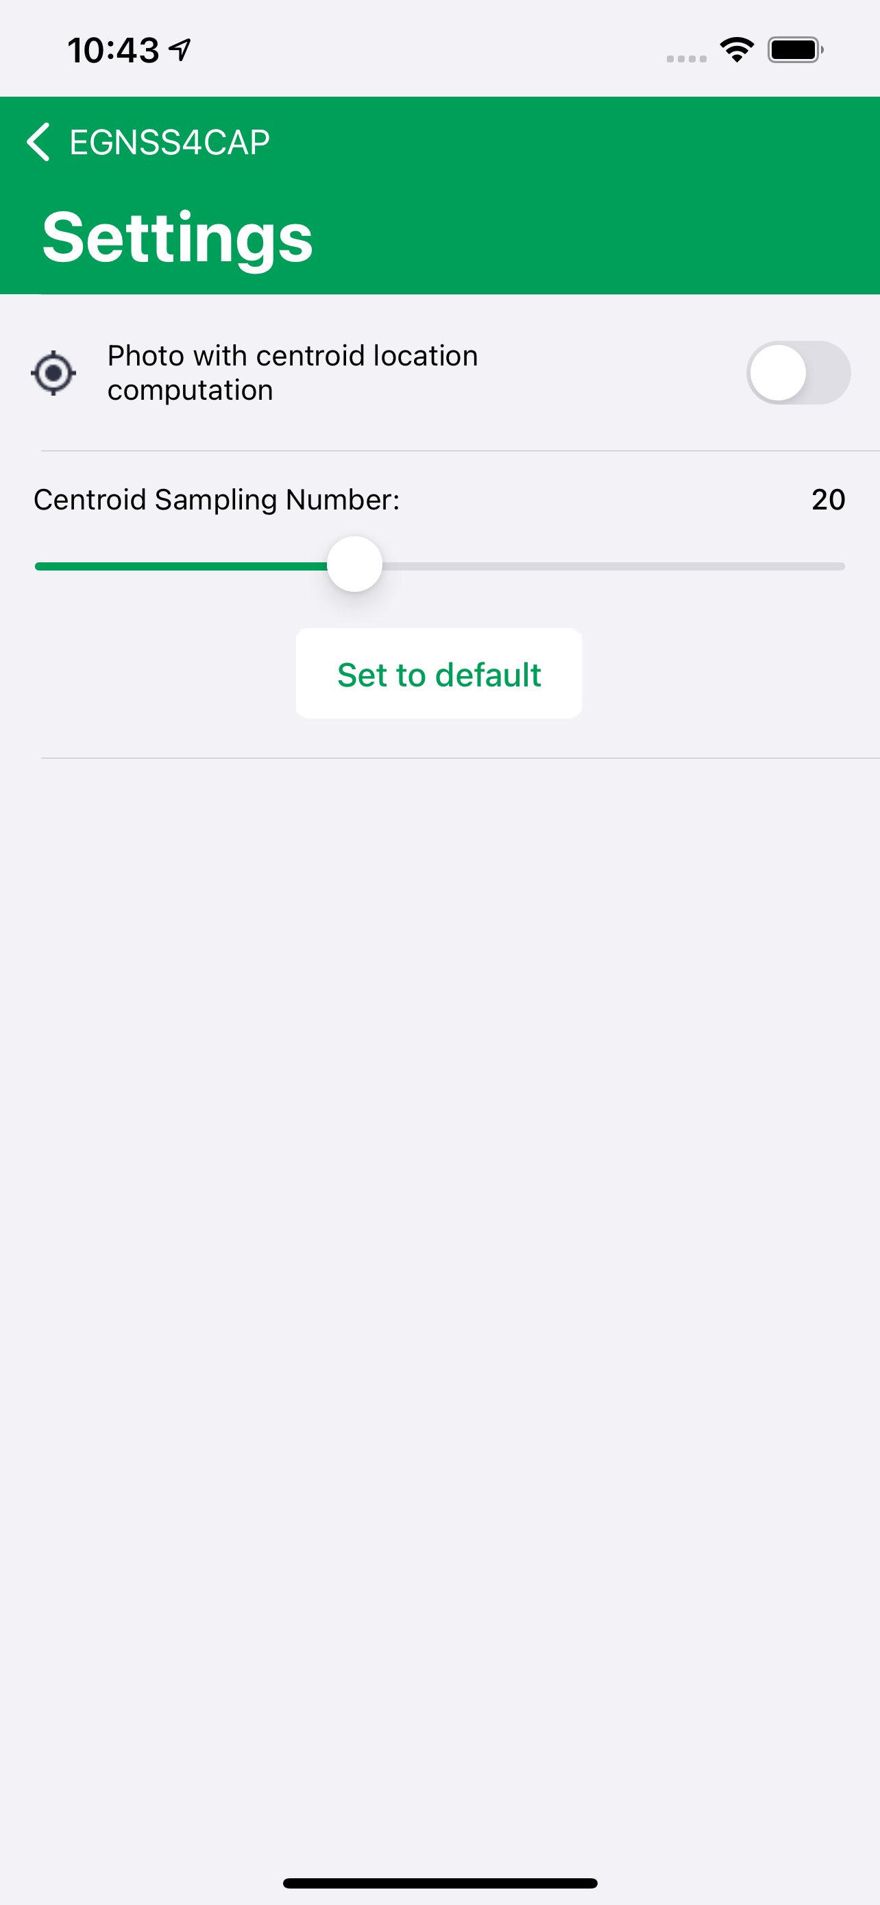

Fig. 17 Settings

* *Photo with centroid location computation* 
  + When capturing an image, location center of gravity information will be added to its metadata.
* *Centroid Sampling Number*
  + Sets the number of samples required to calculate the position center of gravity.
  + Click the *Default* button to set the default number.

Clicking the *SET DEFAULT VALUES* button returns all filter values to the default.

# Web Console Interface

The web console is accessible through the following link: <https://egnss4cap-uat.foxcom.eu/login.php>

## User roles

Farmer role

* Have access to his tasks and photos, but is not able to do any operations.

Officer role

* Have access to all users that belong under his agency, can move tasks between states.

Super-admin role

* Have access to Agency management module. Can create new agencies and manage existing ones.
* Does not have access to standard application.

To log in to the web interface, enter your login details.

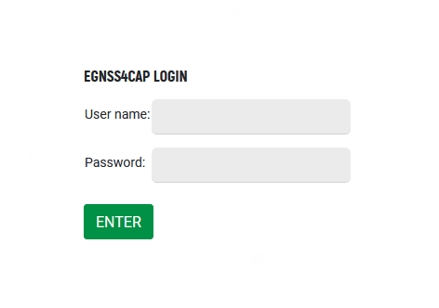

Fig. 19 Web Console login

## Farmer access

The default page after login is the Task list.

### Task List

The bottom part shows the assigned tasks, which can be sorted, filtered and searched. In the top part, points representing individual tasks are displayed on the map. Map is shown by default.

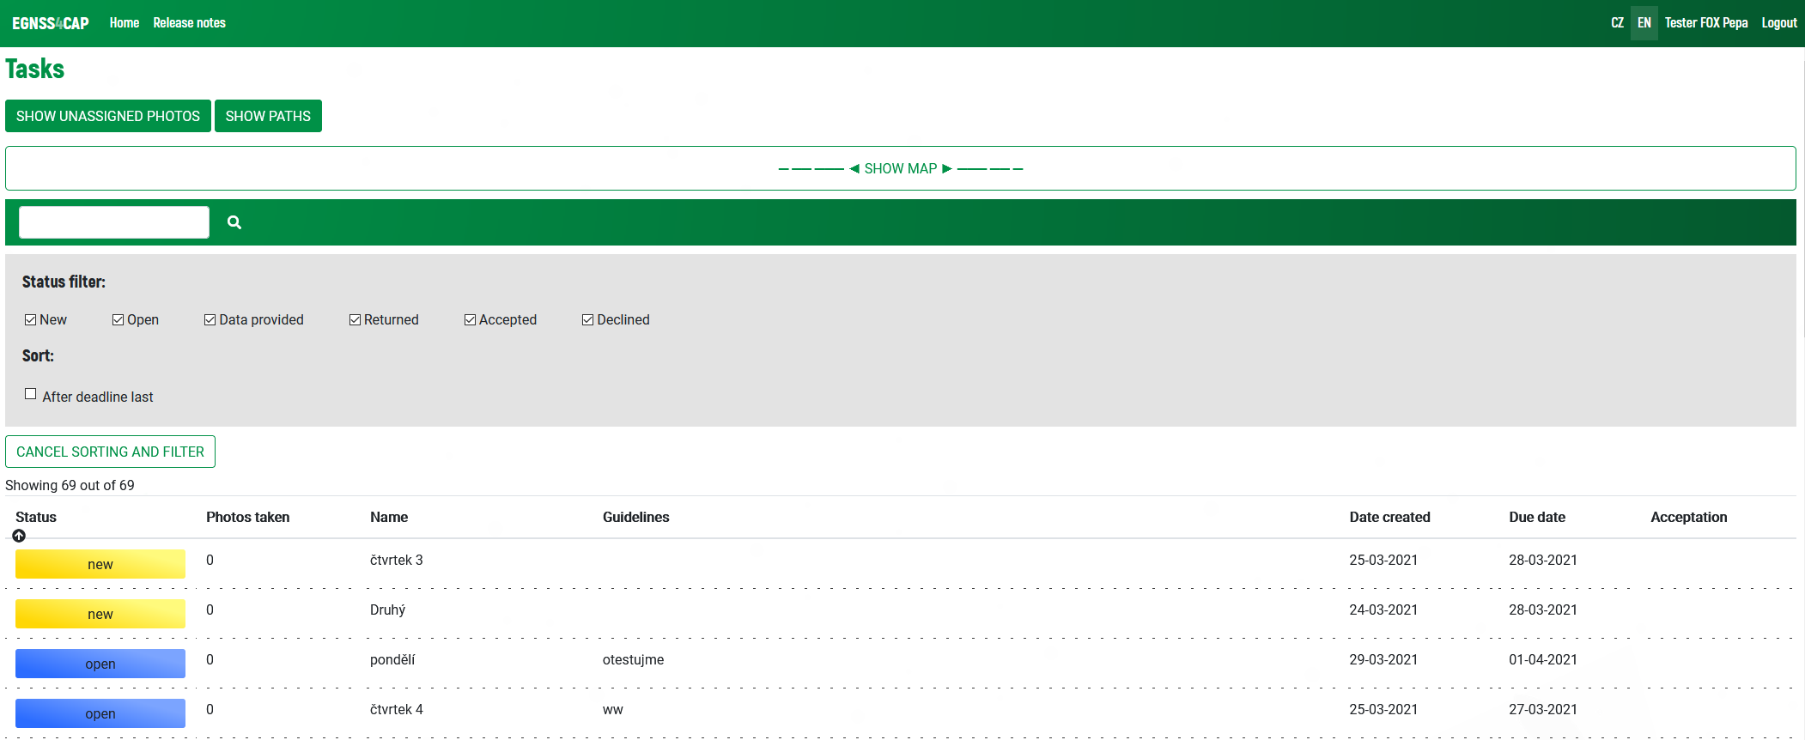

Fig. 20 Tasks and Map

The following options are available for the user:

1. Open task detail (by clicking on the selected row in the list) 
2. Search for tasks by the specific text 
3. Filter tasks by status (by clicking on the selected status) 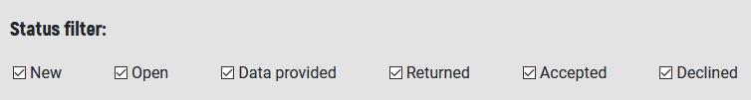
4. Sort tasks in a list by the selected column (by clicking on the column heading) 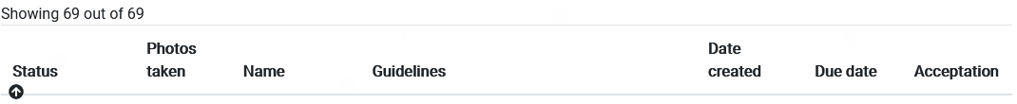 or according to the date of completion of the task (with the button "Passed to the end") 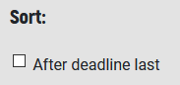
5. Display a page with unassigned photos 
6. Display a page with paths 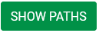
7. Browse the map and open the task detail by clicking on a point on the map

### Task Detail page

This page contains detailed information about the task, as well as photos that were taken for the task. The map shows the position of the photos, the viewing radius of the camera and the direction of the photo. The map can be viewed.

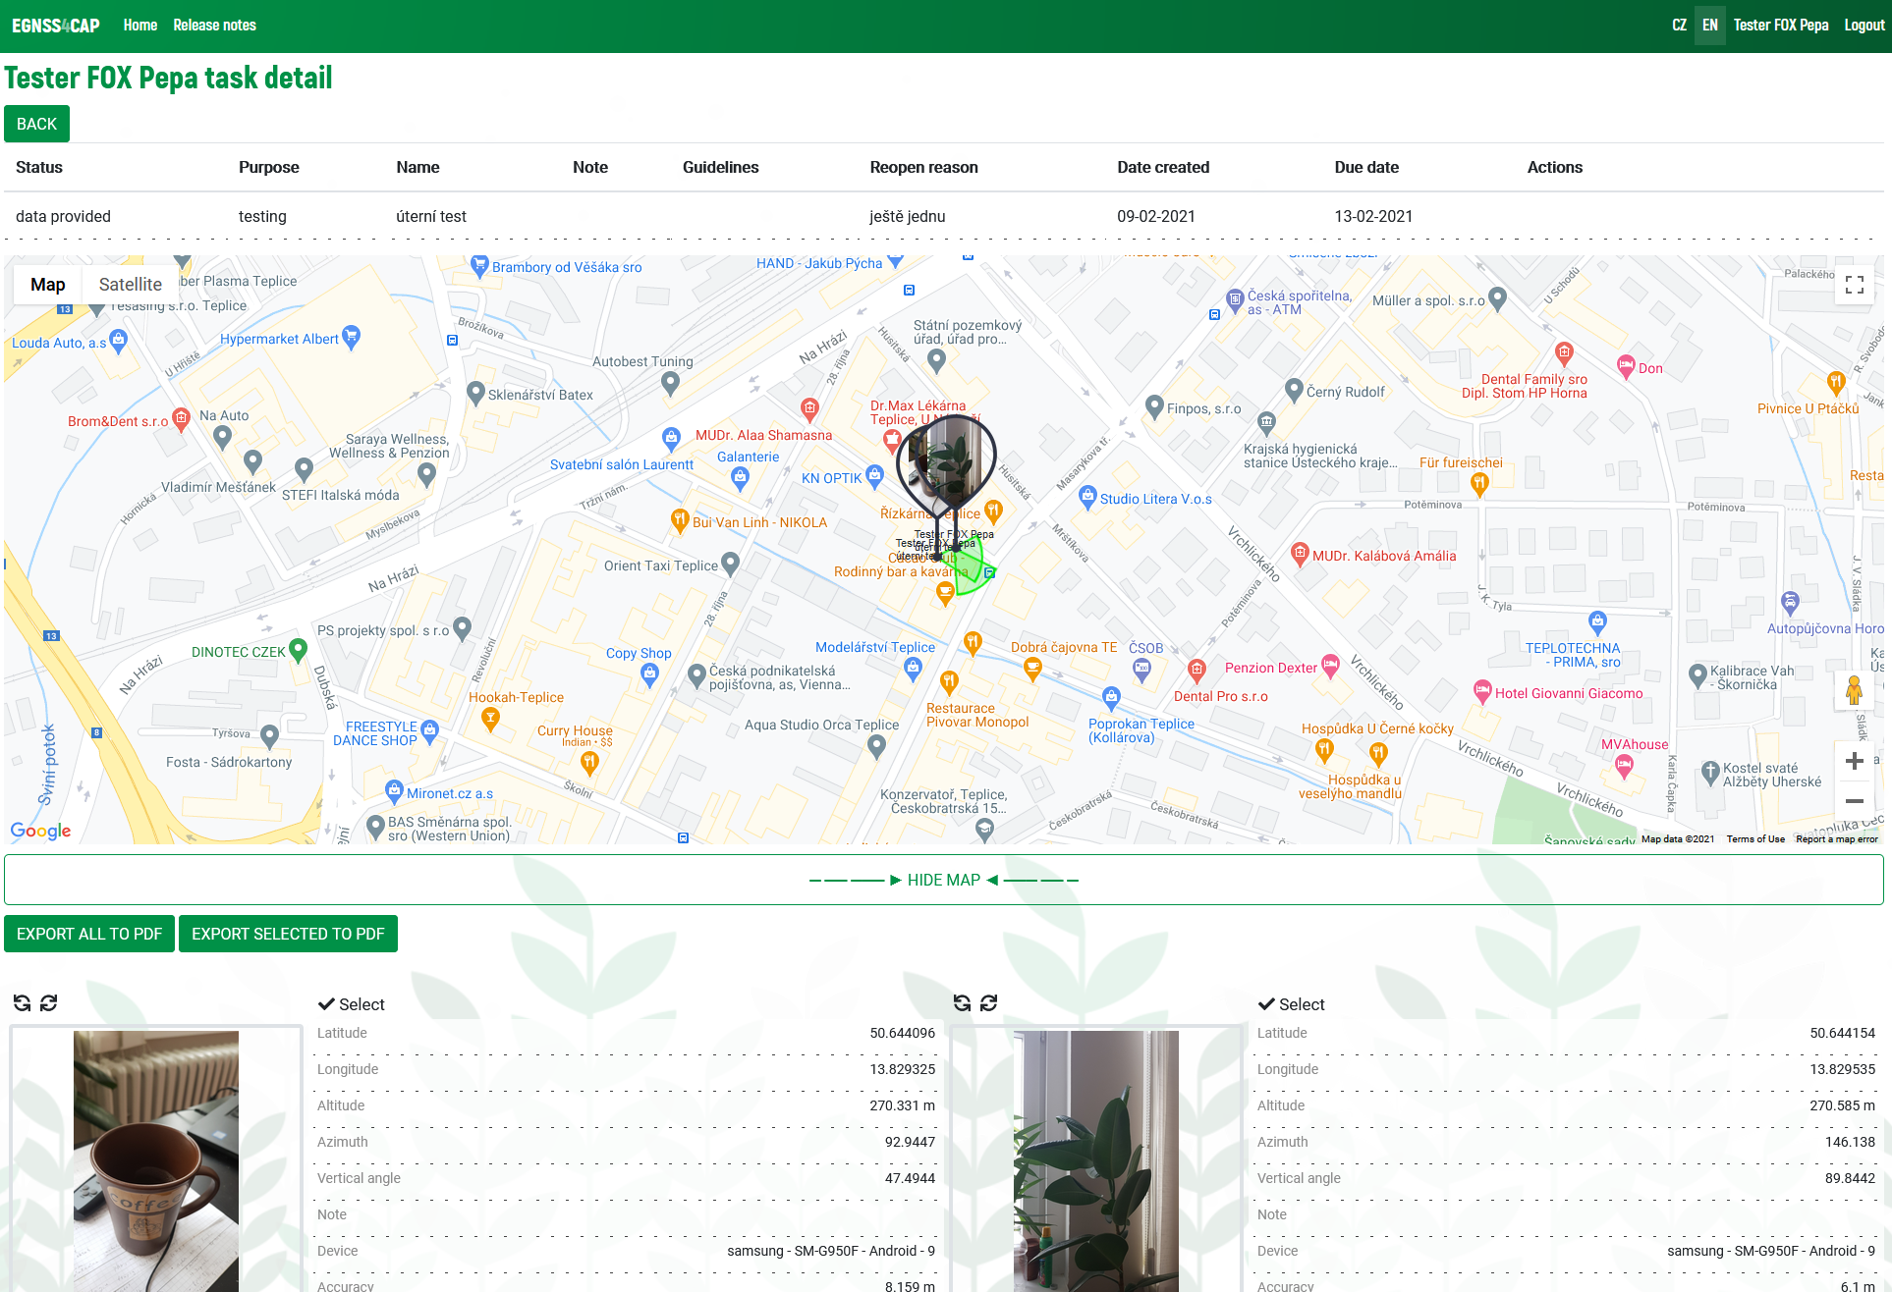

Fig. 21 Task detail

Photos can be rotated here using the buttons:



Click on the photo to open the Photo Gallery (see below).

A table with source data is placed next to each photo.

User can select photos for export to PDF. 



PDF export functionality is described below.

### Standalone photos gallery

At the top of the page, a map is displayed, where the position of individual unassigned photos is marked.

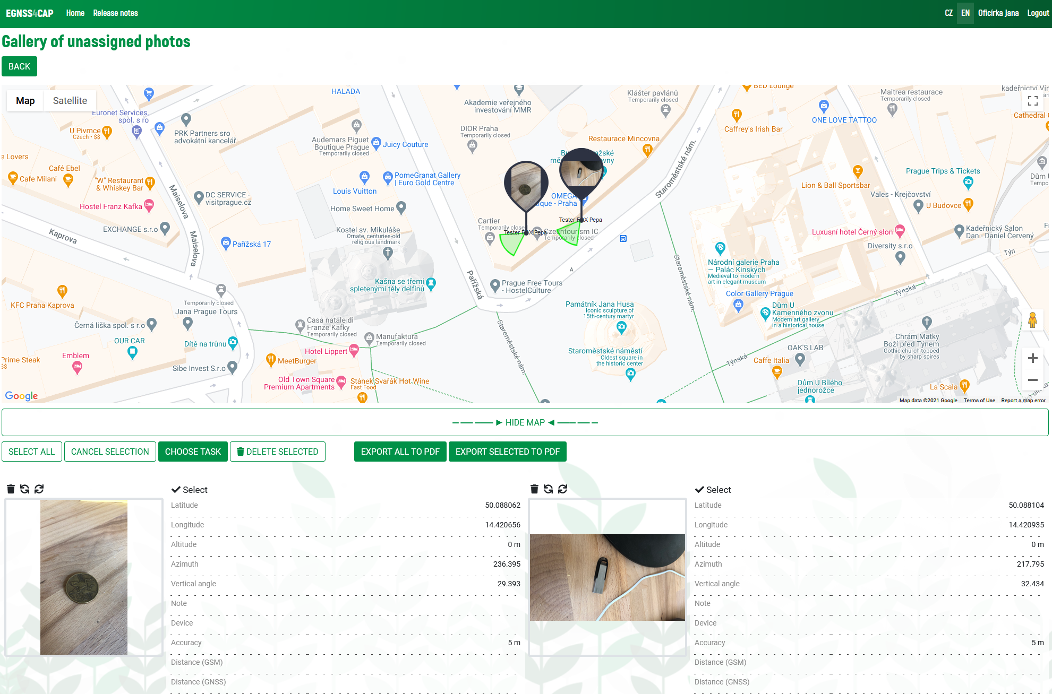

Fig. 22 Standalone task unassigned photos

Below are photos that are not assigned to any task. A table with source data is placed next to each photo.

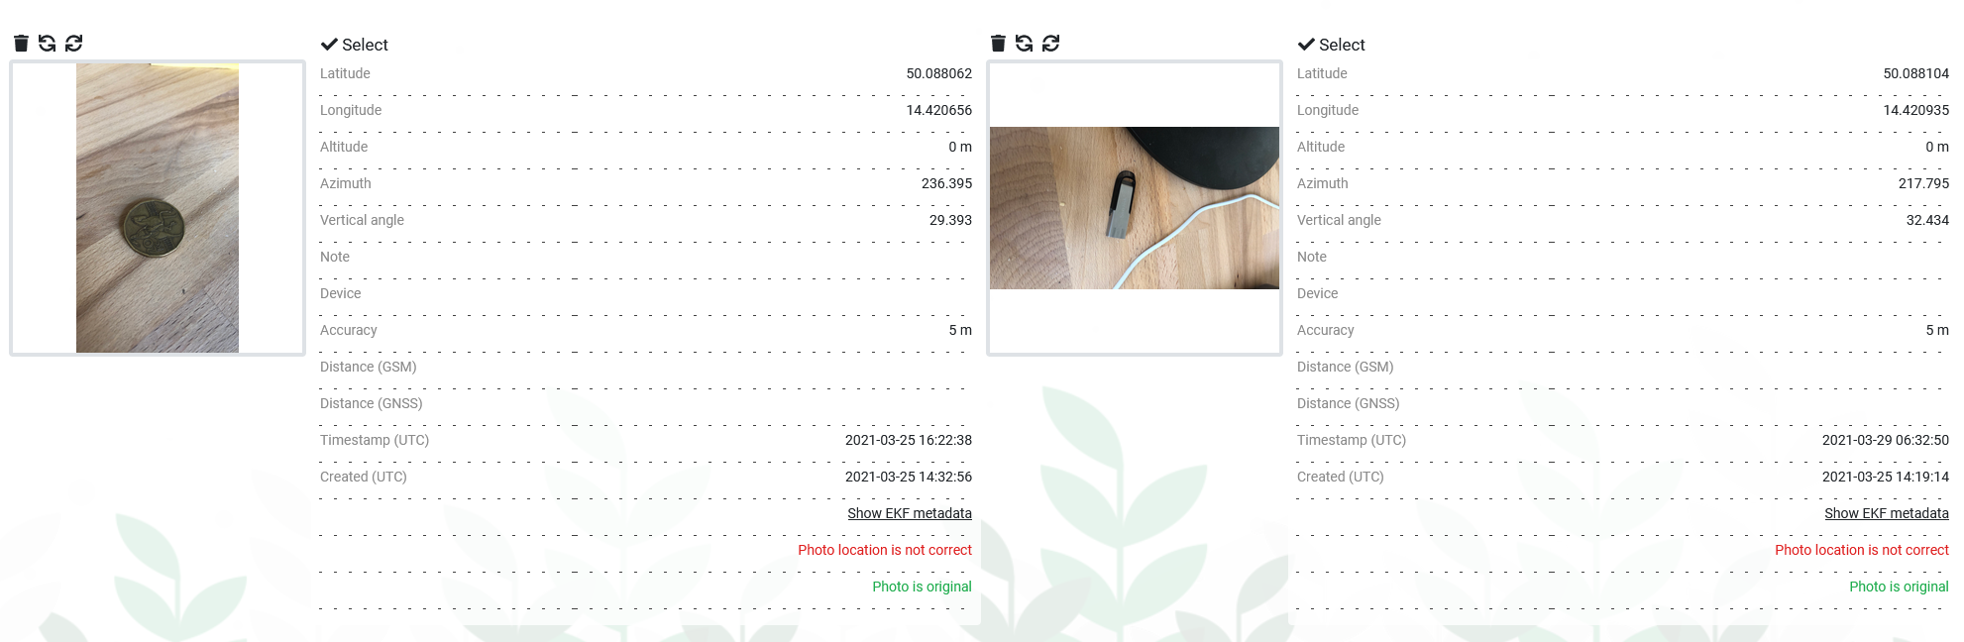

Fig. 23 Unassigned photos

Several options are available to edit the photos:

1. Rotation 
2. Delete 
3. Select for an action 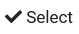
   * By clicking the Select button, the photo is marked for the bulk assignment to a task, to a bulk delete or bulk export to PDF 
   * Selected photos are marked by the red rectangle.
4. Open photo gallery – click on the photo (see below)

When selecting bulk actions, the following options are available:



1. Select all
   * Selects all unassigned photos
2. Cancel selection
   * Cancels current selection
3. Select task
   * Displays a page where you can select the task to which the selected photos are to be assigned. For recapitulation, the photos that were marked on the previous page are displayed here. Below the photos, a selection box is available, where it is necessary to select the target task. The map is displayed at the top of the page.
   * After clicking the *Confirm button*, a dialog box will appear, where by pressing the *OK* button, the process of assigning photos will be completed.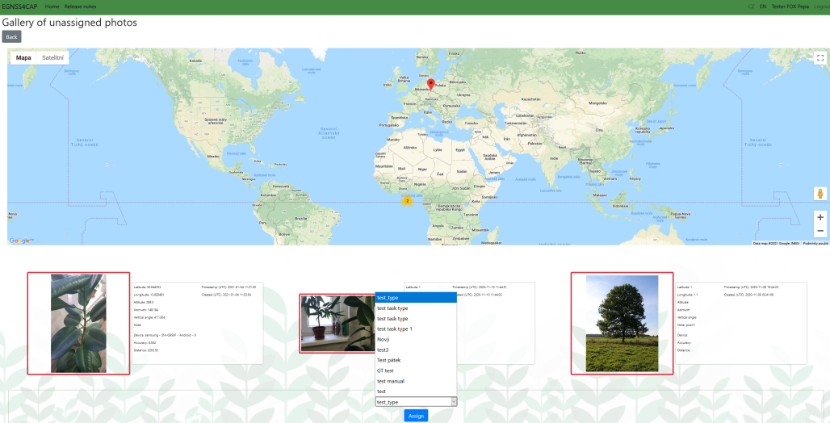
   * Once finished, the user is navigated back to the Task list screen.
4. Delete selected photos
   * Displays a dialog box where, after confirmation by pressing OK, the marked photos will be deleted

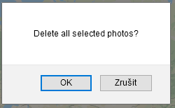

1. Export all to PDF
   * This button pass all photos to PDF export
2. Export selected to PDF
   * This button pass selected photos to PDF export

PDF export functionality is described below.

### Photo gallery

The gallery is accessible from various places in the application, always by clicking on the photo.

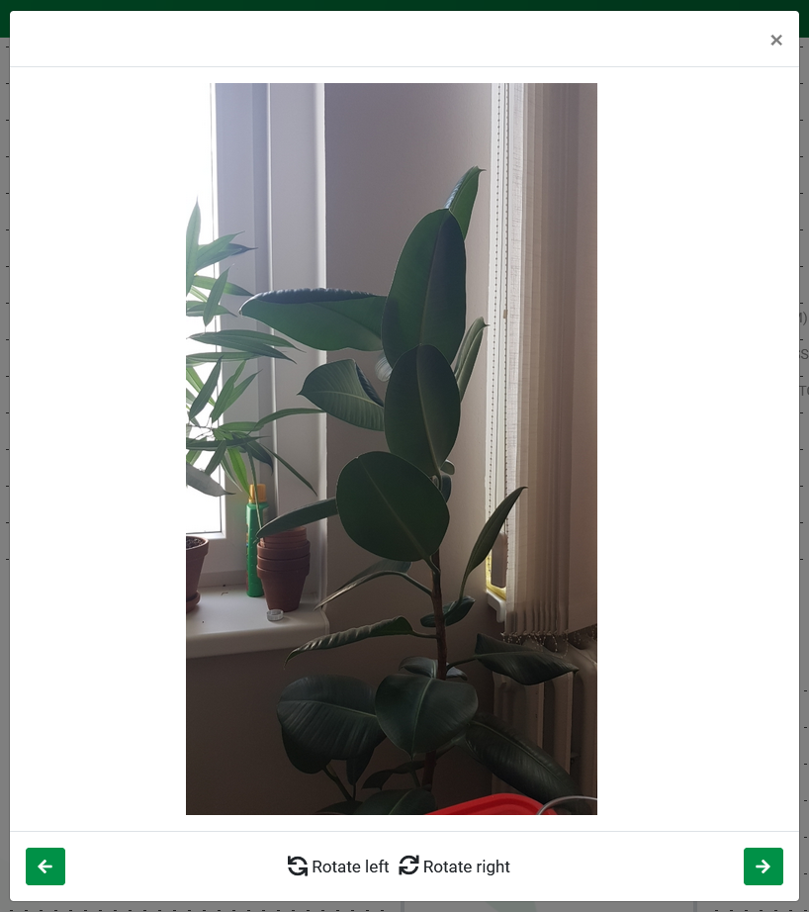

Fig. 24 Photo gallery

At the bottom is the control panel, where you can rotate the photo and jump between photos using the arrows.



Clicking on a photo in the gallery opens a new window in which the photo is loaded in its maximum size and it is possible to zoom in (Zoom in) or zoom out (Zoom out), or set the default size (Reset zoom). Zoom change is for preview only, and will not be saved.



### User paths

At the top of the page, a map is displayed, where all of the paths are shown. 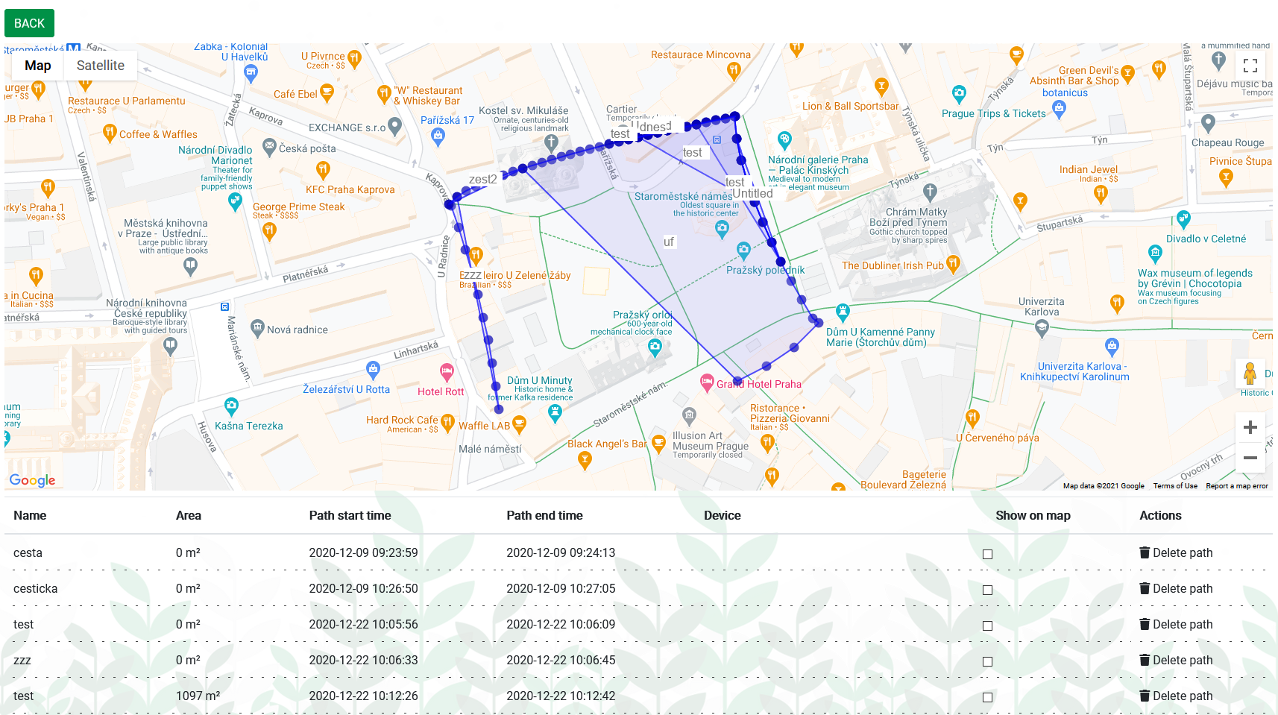

Fig. 25 User paths

Paths can be highlighted by clicking on the map. Each path has displayed points of which it is composed. Click on the point to display a table with detailed information.

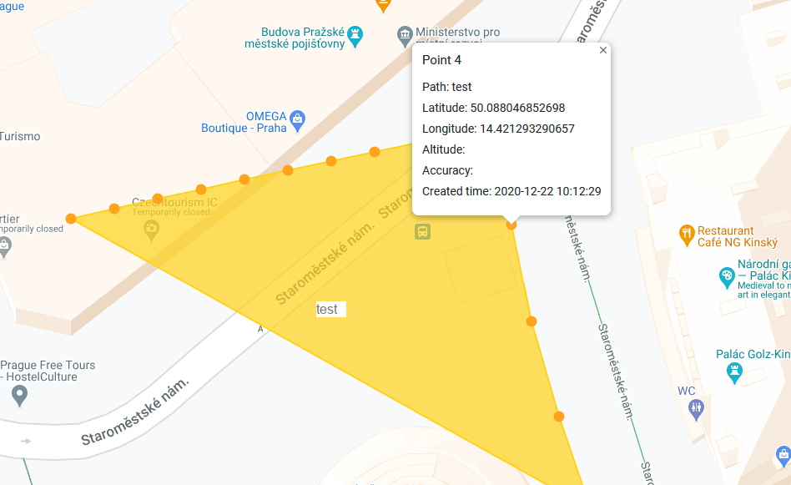

Fig. 26 Highlighted path with point detail

Below is a list of paths of the selected user. Only selected routes can be displayed on the map using the checkbox in the Show on map column.

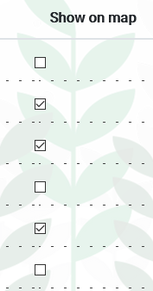

Paths can be deleted using delete path. 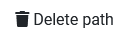

### Generating PDF documents

The functionality of exporting data to PDF is triggered by buttons:



The buttons are available at the Unassigned photos page and the Task detail page.

The button “Export all to PDF” passes all photos at current page to a PDF export and open a PDF prepare page.

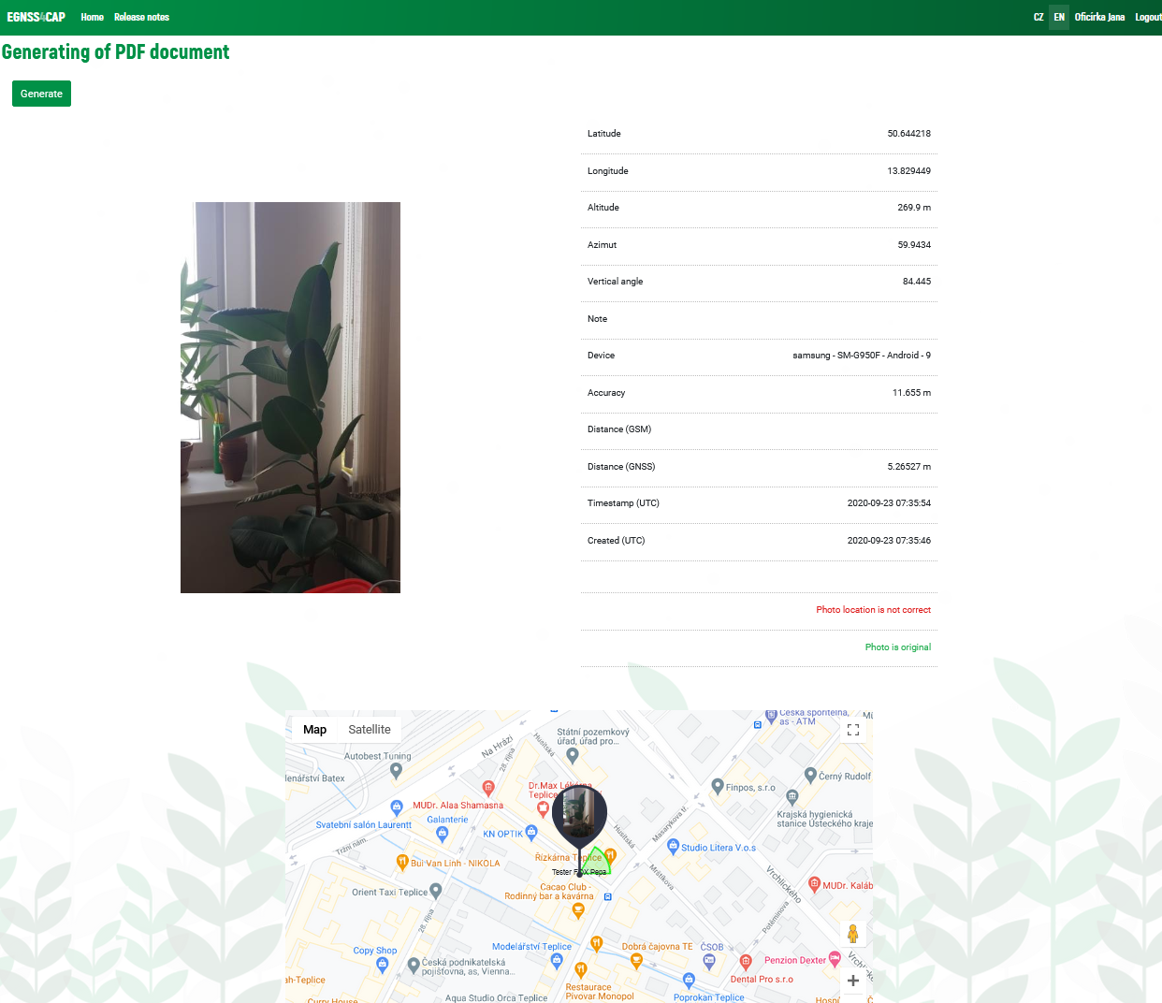

Fig. 27 PDF generating prepare page

On the PDF prepare page are displayed all the photos which are going to be exported. Every photo has its own map generated especially for the PDF which can be adjusted before export. Once everything is prepared (progress loader disappears), export is executed by clicking the “Generate” button.

Generating PDF can take some time, which depends on total count of exported photos. The user is informed by progress loader.

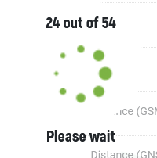

Fig. 28 Progress loader

The button “Export selected to PDF” passes to the PDF export just the selected photos:

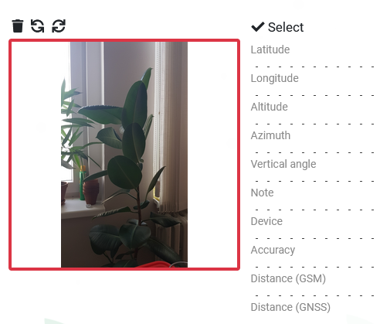

Fig. 29 Selected photo

Next steps of the exporting process are identical to process steps described above (“Export all to PDF”).

### Map



Fig. 30 Map

Points that represent photos or tasks displayed on the currently open page are always displayed on the map.

The zoom of the map is automatically set so that all points are visible in the displayed area of the map. The zoom can be adjusted manually (with the mouse wheel or using the control panel on the map).

The points are color-coded according to the active status of the task. The color of the points corresponds to the color of the status in the task list. Points representing unassigned photos are not color-coded.



Fig. 31 Task status list

Click on a map point to open the task detail.



Fig. 32 Map - a middle zoom

Due to the possible high concentration of points in a small area, the points are grouped into one group with a numerical expression of the number of points in a given place. Click on the group icon to zoom in on the group position.

As you zoom in greatly on the map, points are changed to preview banners that display a specificuser, the name of the task, the photo and the radius of the camera view at the time the photo was taken. Clicking on this banner opens the following task detail.

Polygons of existing plots and their names are also shown.

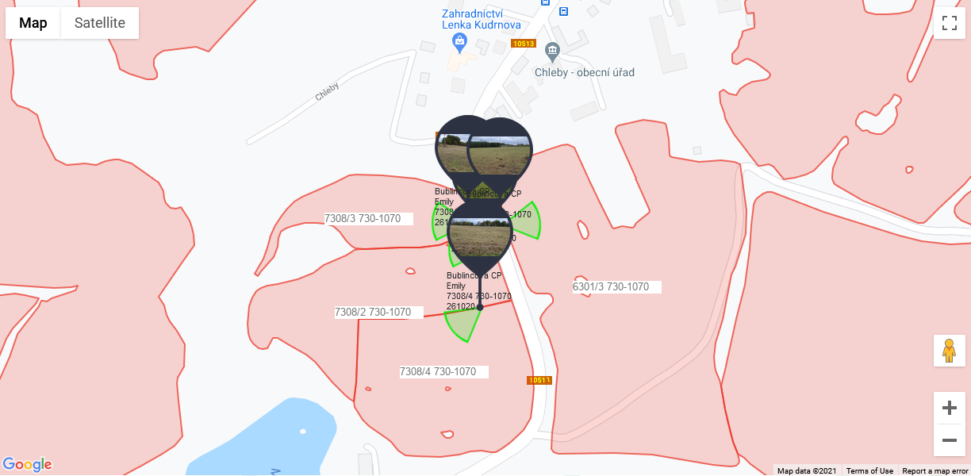

Fig. 33 Map – detail zoom in

## Administrator

After logging in, the user management page is displayed. Graphically and functionally, the application is the same as in the approach for users.

In the administrator access, controls are added as described below.

### User management

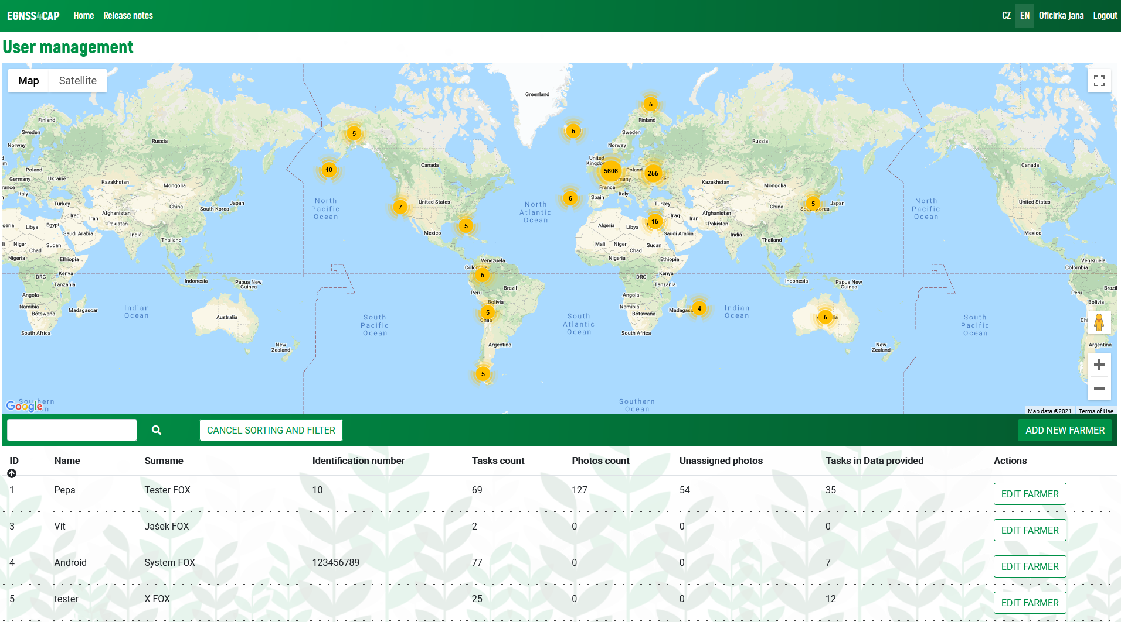

Fig. 34 User management

At the top is a map with all the tasks of all farmers. At the bottom is a list of farmers.

The following options can be used:

1. Search for a farmer according to the entered text 
2. Sort farmers in the list by the selected column (by clicking on the column heading) 
3. Open farmer detail 
4. Add a new farmer 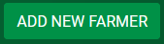
   * By clicking on the button, a table is displayed in which it is necessary to fill in the data of the new farmer. The creation of a new farmer is confirmed by pressing the *Save* button.
   * The entered login and password will be used by the farmer to access the application. 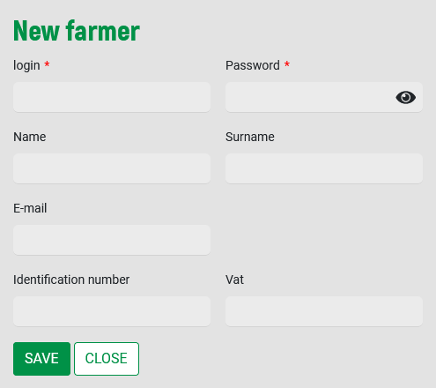
5. Edit an existing farmer 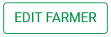
   * Clicking the button displays the same table as when creating a new farmer. In this case, the table is pre-populated with the data of the selected farmer. The data can be edited in the table (except for the login) and their modification can be confirmed with the *Save* button.
   * If the password field is left blank, the password remains the same.

### Farmer Detail

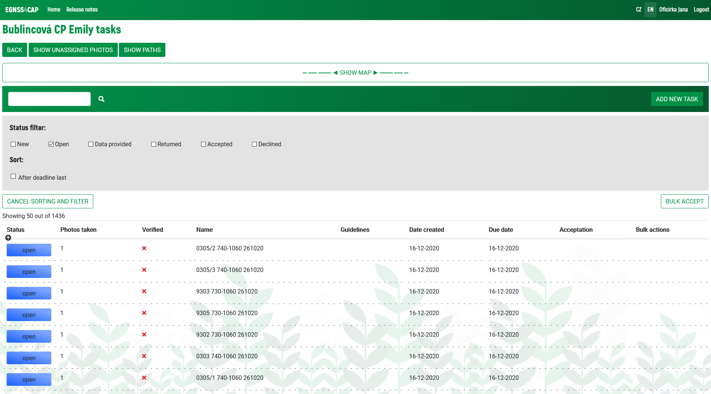

Fig. 35Tasks - Administrator

This page is the same as in the farmer's approach, extended by the following:

1. New task 
   * Clicking on the button displays a table in which it is necessary to fill in the data of the new task. The creation of a new task is confirmed by pressing the Save button. A new task is created with the status "*new*". 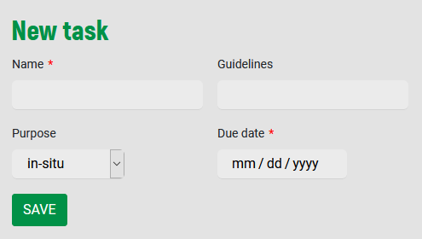
2. Bulk task approval function
   * To perform a bulk approval, you must first mark the tasks to be approved. By checking the box for the required tasks in the right column of the table.
   * Only tasks with the status "*data provided*" can be approved.
   * After pressing the Approve in bulk button, a dialog box is displayed, where after pressing the OK button, the bulk action will be performed.
   * Approval of tasks changes their status to "*data checked*" and the acceptance status to "*Approved*".
3. Photos
   * The *Examined* column graphically shows whether the photo checks were OK or not.
   * This involves checking the correctness of the position and checking the originality of the photo.
   * Complete control information is displayed in the task detail for each photo.

### Task Detail

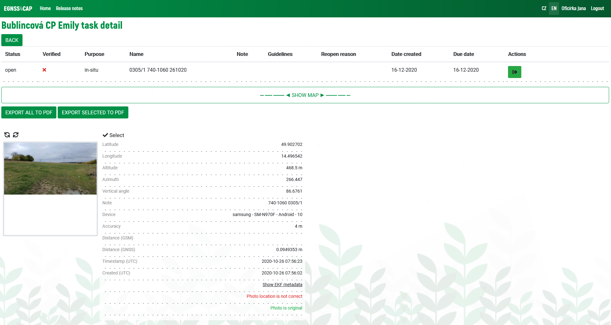

Fig. 36 Task detail – Administrator view

This page is the same as in the farmer's approach, extended by the following:

1. Actions
   1. Approve 
      * This action is available with the status "*data provided*", and allows you to approve a task.
      * After pressing the *Approve* button, a dialog box is displayed, where after pressing OK the action is done
      * The result of the action is the setting of the status "*data checked*" and the reception status "*Approved*".
   2. Reject 
      * This action is available with the status "*data provided*", and results in the rejection of a task.
      * After pressing the *Reject* button, a dialog box is displayed, where it is possible to enter a comment for rejection, and after pressing OK, the action will be performed.
      * The result of the action is the setting of the status "*data checked*" and the acceptance status "*Rejected*".
   3. Return to farmer 
      * This action is available with the status "*data provided*". It allows you to return the task to the farmer for completion.
      * After pressing the Undo button, a dialog box is displayed, where it is possible to enter a comment to be undone, and after pressing OK, the action will be performed.
      * The result of the action is the setting of the status "*returned*".
   4. Move to “*data provided*“ 
      * This event is available with an "*open*" status. It allows you to move the task to "*data provided*" status.
      * After pressing the *Move* button, a dialog box is displayed, where it is possible to enter a comment, and after pressing OK, the action will be performed.
      * The result of the action is the setting of the status "*data provided*".
   5. Delete 
      * This action is available with the status "*new*". It allows you to delete a task.
      * After pressing the Delete button, a dialog box is displayed, where after pressing OK the action is performed.
      * The result of the action is deleting of the task.
2. Verification of photos
   * + The *Examined* column graphically shows whether the photo checks were OK or not. This involves checking the correctness of the position and checking the originality of the photo.
3. View complete photo review information
   * + The table of photo data shows the results of the performed checks in color.

## Super-administrator

After logging in, the Agency management page is displayed.

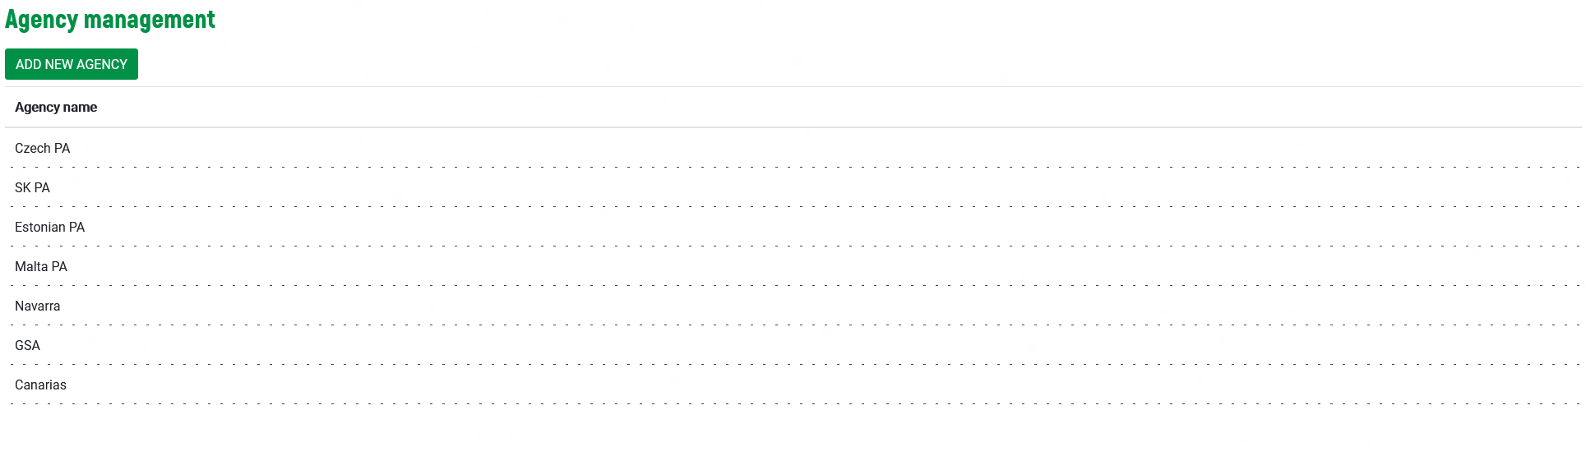

Fig. 37 Agency management

### Agency list

This page offers the following features:

1. Add new agency 
   * Clicking on the button displays a table in which it is necessary to fill in the name of the new agency. The creation of the agency is confirmed by pressing the Save button. 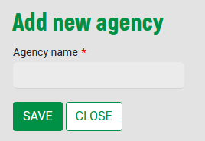
2. Open detail of the agency by clicking on a row of specified agency.



### Agency detail

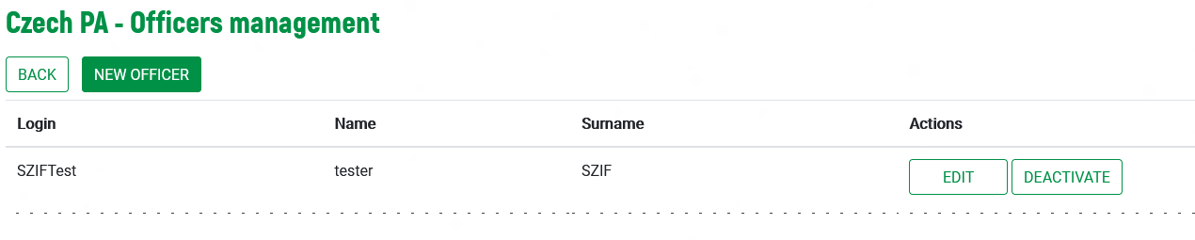

Fig. 38 Officers management

1. Add a new officer 
   * By clicking on the button, a table is displayed in which it is necessary to fill in the data of the new officer. The creation of a new officer is confirmed by pressing the *Save* button.
   * The entered login and password will be used by the farmer to access the application. 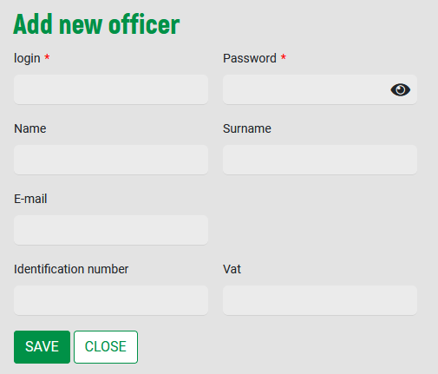
2. Edit an existing officer 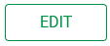
   * Clicking the button displays the same table as when creating a new officer. In this case, the table is pre-populated with the data of the selected officer. The data can be edited in the table (except for the login) and their modification can be confirmed with the *Save* button.
   * If the password field is left blank, the password remains the same.
3. Deactivate an existing officer 

* After pressing the Deactivate button, a dialog box is displayed, where after pressing OK the action is performed.
* The result of the action is deactivation of the selected officer.
* The deactivated officer will be no more able to log in into application.

# Annex: Hosting and installing the EGNSS4CAP web console

## Hosting requirements

* Php7 engine
* MySQL 8 database server
* Apache2 web server

## Server resources requirements

* min 8GB RAM
* min 2core cpu
* min 10GB disk space

## Installation steps for the webconsole

* copy the web console files into the selected webroot directory
* create VirtualHost section in the Apache2 configuration and point it to selected directory
* make sure that there is set a directive DirectoryIndex index.php
* write the database name, database user and the corresponding password into the web console configuration file
* run [http://your-domain.tld](http://your-domain.tld/)